**CAPSTONE PROJECT – 2**

**DEVOPS**

**DONE BY  
RANJITH KUMAR**

You are hired as a DevOps Engineer for Analytics Pvt Ltd. This company is a product based organization which uses Docker for their containerization needs within the company. The final product received a lot of traction in the first few

weeks of launch. Now with the increasing demand, the organization needs to have a platform for automating deployment, scaling and operations of application

containers across clusters of hosts. As a DevOps Engineer, you need to implement a DevOps lifecycle such that all the requirements are implemented without any change in the Docker containers in the testing environment. Up until now, this organization used to follow a monolithic architecture with just 2 developers. The product is present on:

<https://github.com/hshar/website.git>

**Following are the specifications of the lifecycle:**

1. Git workflow should be implemented. Since the company follows a monolithic architecture of development, you need to take care of versioncontrol. The release should happen only on the 25th of every month.

2. CodeBuild should be triggered once the commits are made in the master branch.

3. The code should be containerized with the help of the Dockerfile. The Dockerfile should be built every time if there is a push to GitHub. Create a custom Docker image using a Dockerfile.

4. As per the requirement in the production server, you need to use the Kubernetes cluster and the containerized code from Docker Hub should be deployed with 2 replicas. Create a NodePort service and configure the same for port 30008.

5. Create a Jenkins Pipeline script to accomplish the above task.

6. For configuration management of the infrastructure, you need to deploy the configuration on the servers to install necessary software and configurations.

7. Using Terraform, accomplish the task of infrastructure creation in the AWS cloud provider.

**STEPS:**

1.Create an EC2 instance.

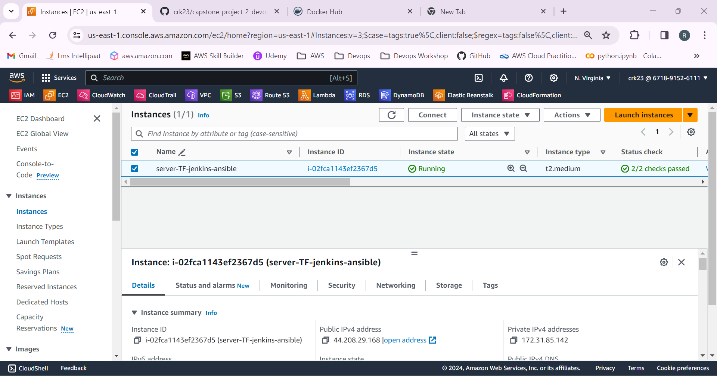

2.Login to the instance.

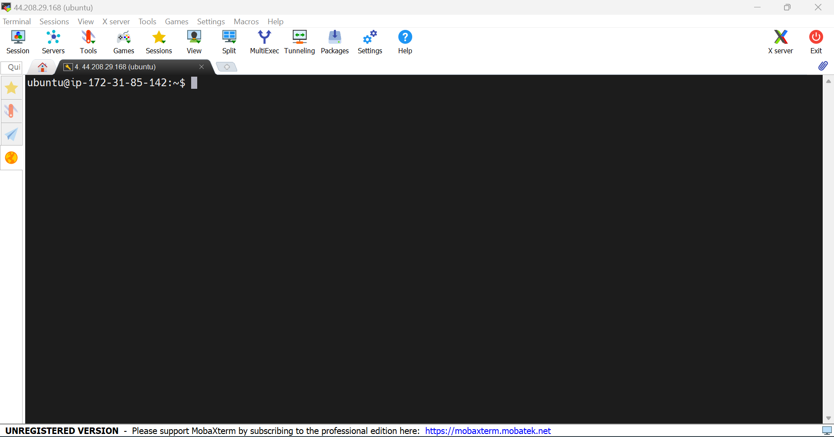

3.Installed terraform in the instance.

wget -O- https://apt.releases.hashicorp.com/gpg | sudo gpg --dearmor -o /usr/share/keyrings/hashicorp-archive-keyring.gpg

echo "deb [signed-by=/usr/share/keyrings/hashicorp-archive-keyring.gpg] https://apt.releases.hashicorp.com $(lsb_release -cs) main" | sudo tee /etc/apt/sources.list.d/hashicorp.list

sudo apt update && sudo apt install terraform

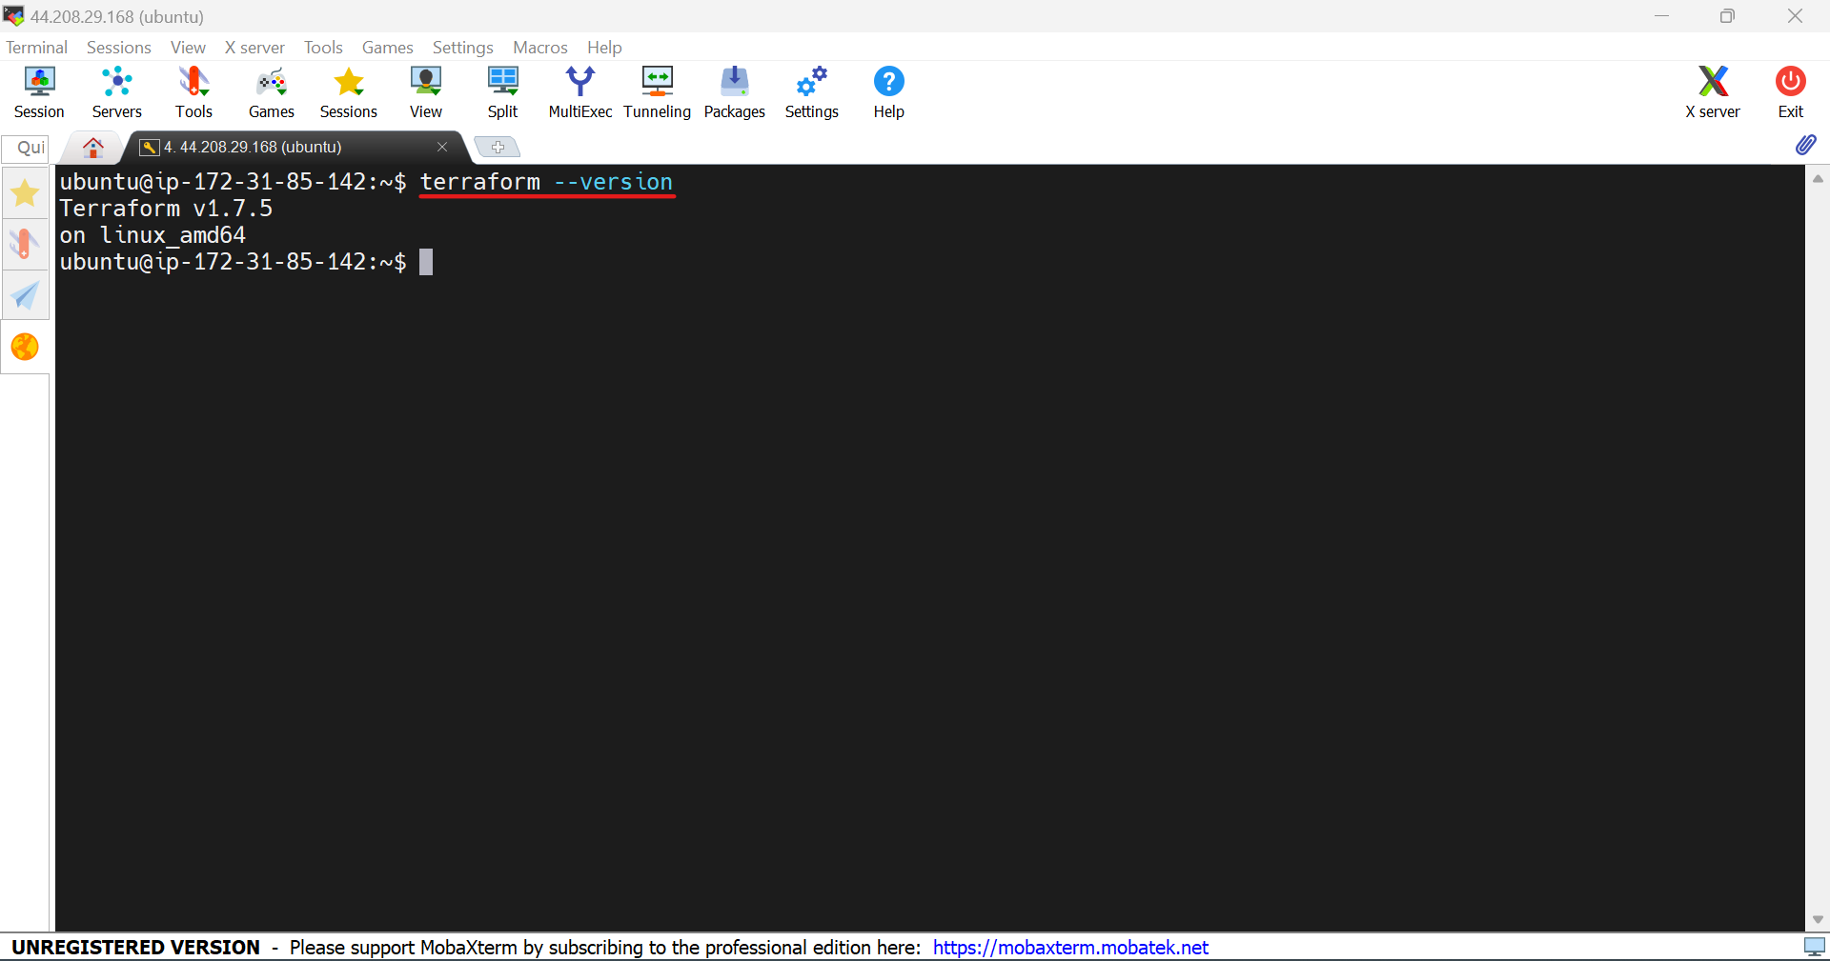

4.Create a tf file to create 2 more instances in us-east-1 region which will be kmaster and kslave.

provider "aws" {

secret_key = ""

access_key = ""

region = "us-east-1"

}

resource "aws_instance" "K8-M" {

ami = "ami-080e1f13689e07408"

instance_type = "t2.medium"

key_name = "neww"

tags = {

Name = "Kmaster"

}

}

resource "aws_instance" "K8-S1" {

ami = "ami-080e1f13689e07408"

instance_type = "t2.medium"

key_name = "neww"

tags = {

Name = "Kslave1"

}

}

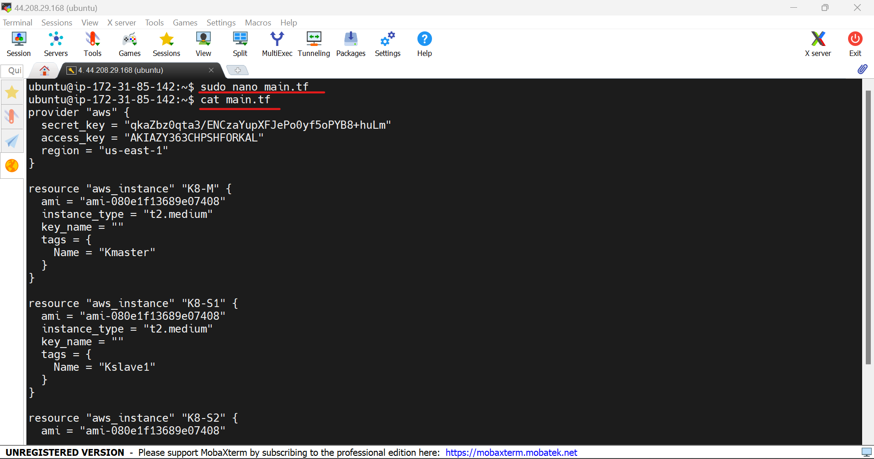

5.Use the commands **terraform init , terraform plan , terraform apply**  to create the infrastructure.

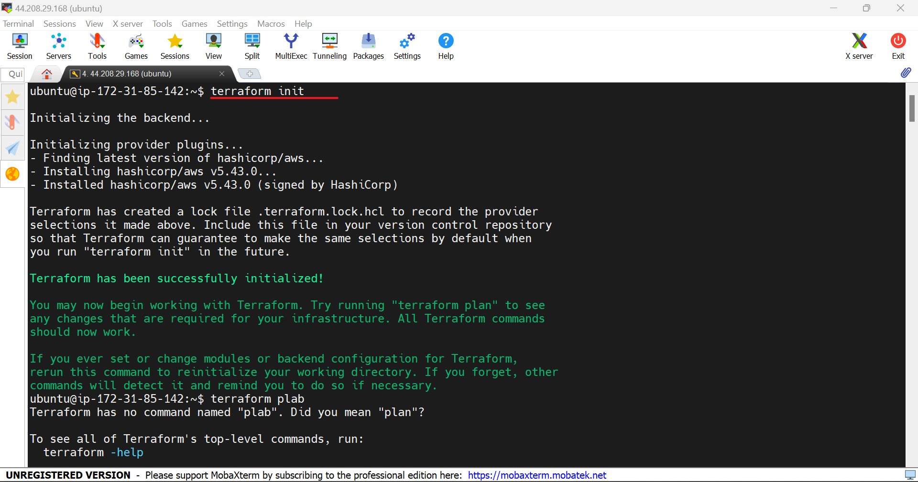

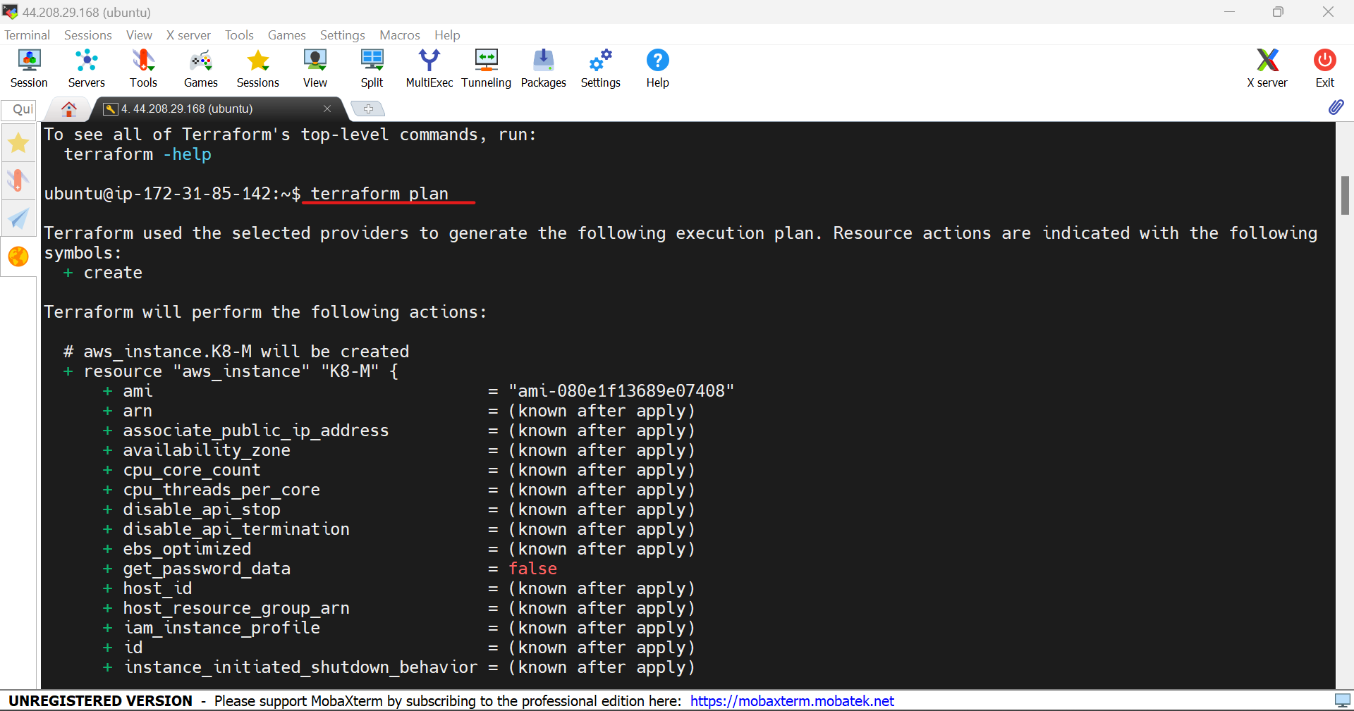

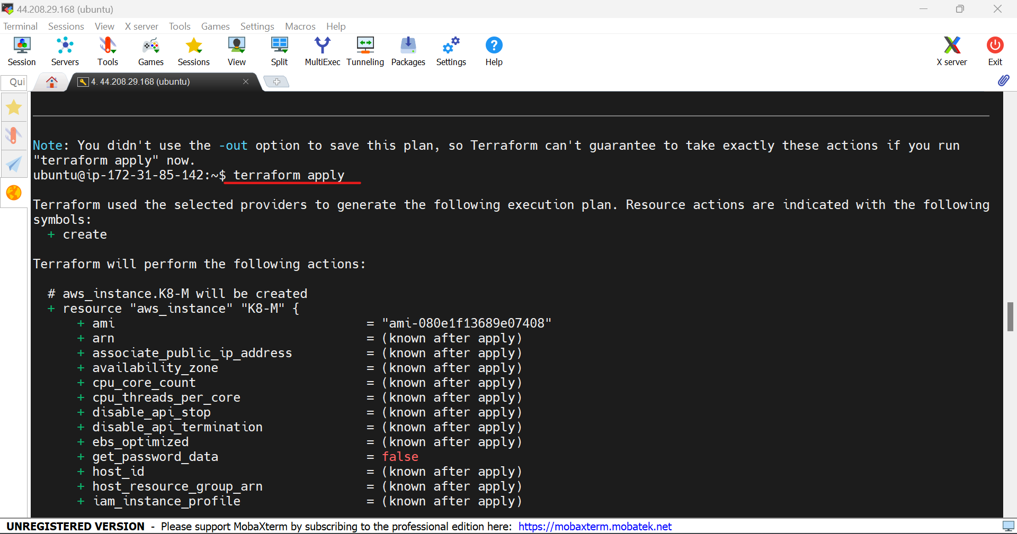

6.EC2 instances has been created using the terraform.

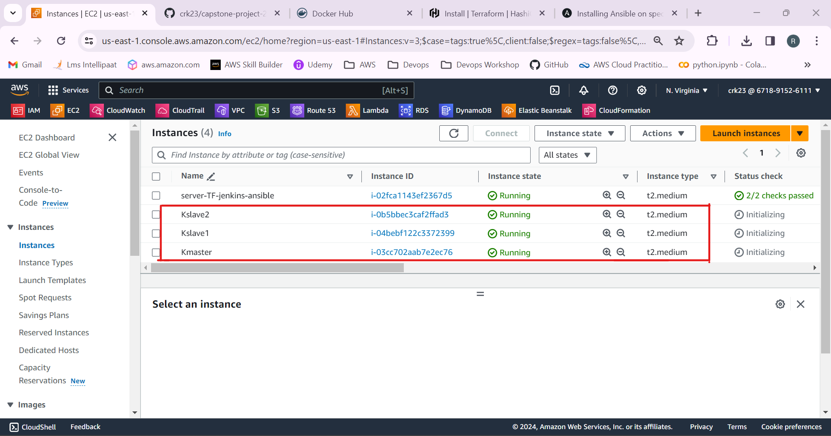

7.Install ansible on the master mahine.

sudo apt update

sudo apt install software-properties-common

sudo add-apt-repository --yes --update ppa:ansible/ansible

sudo apt install ansible

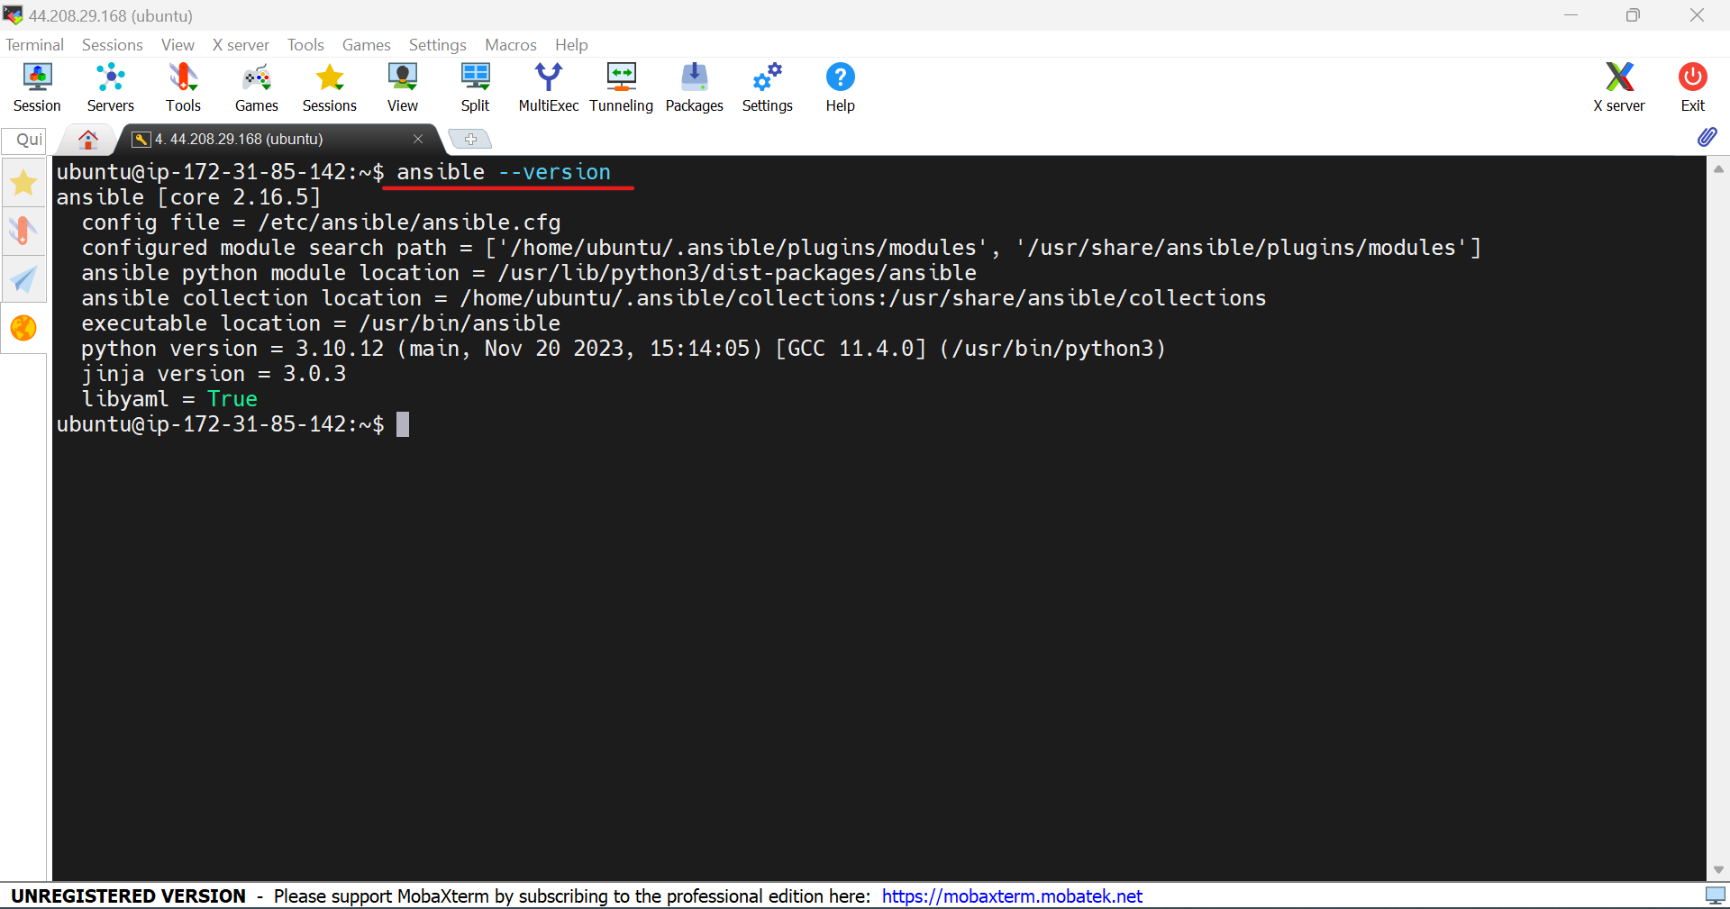

8.Login to the kmaster and kslave instances.

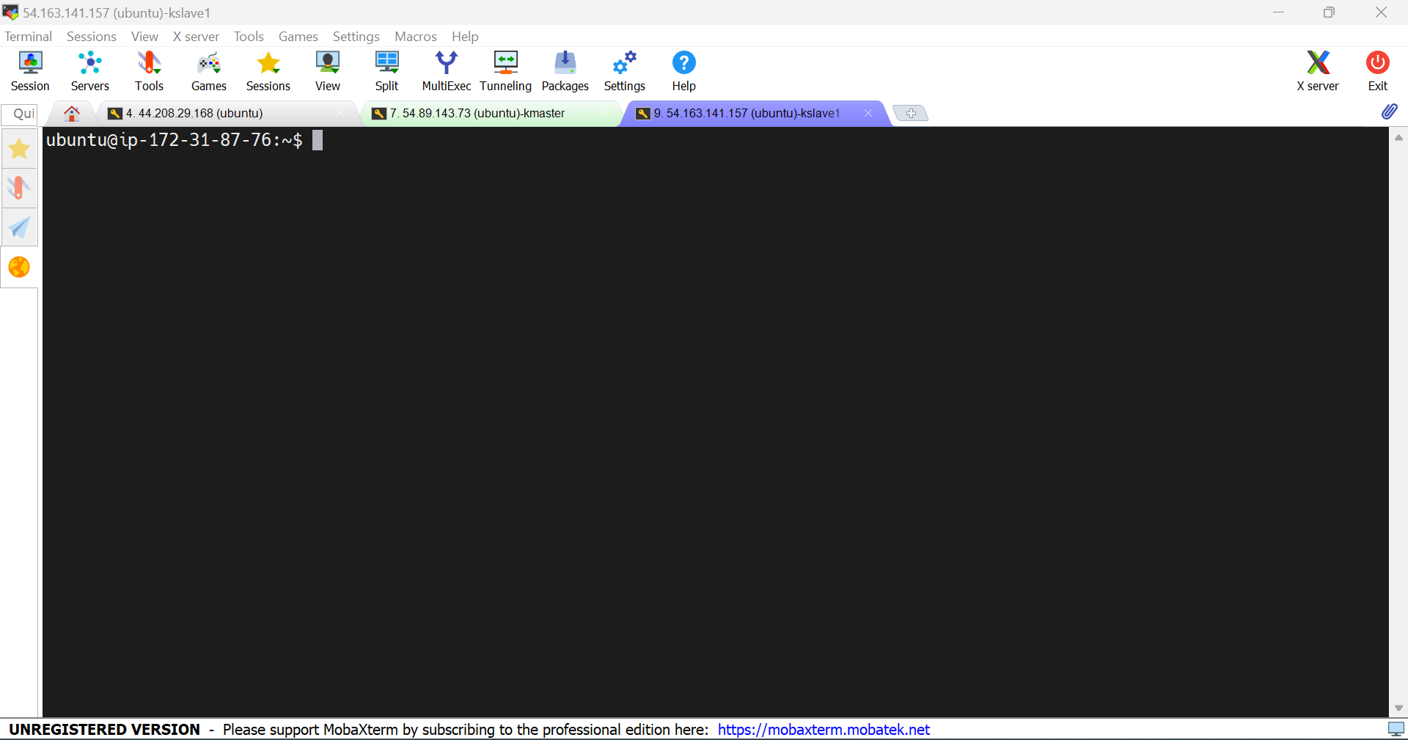

9.In master machine use the command **ssh-keygen**  to create a public key. Copy the public key and paste it in the kmaster and kslave.

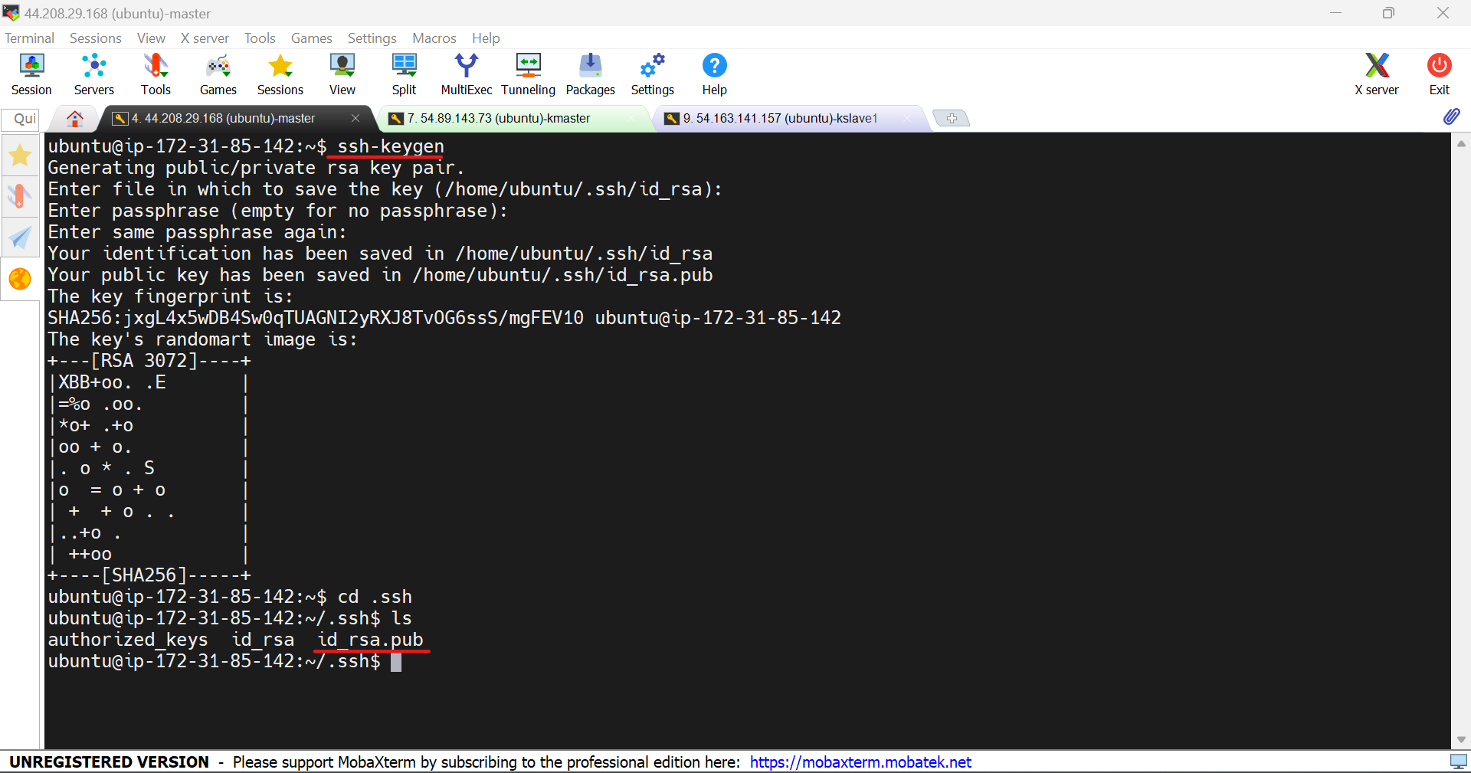

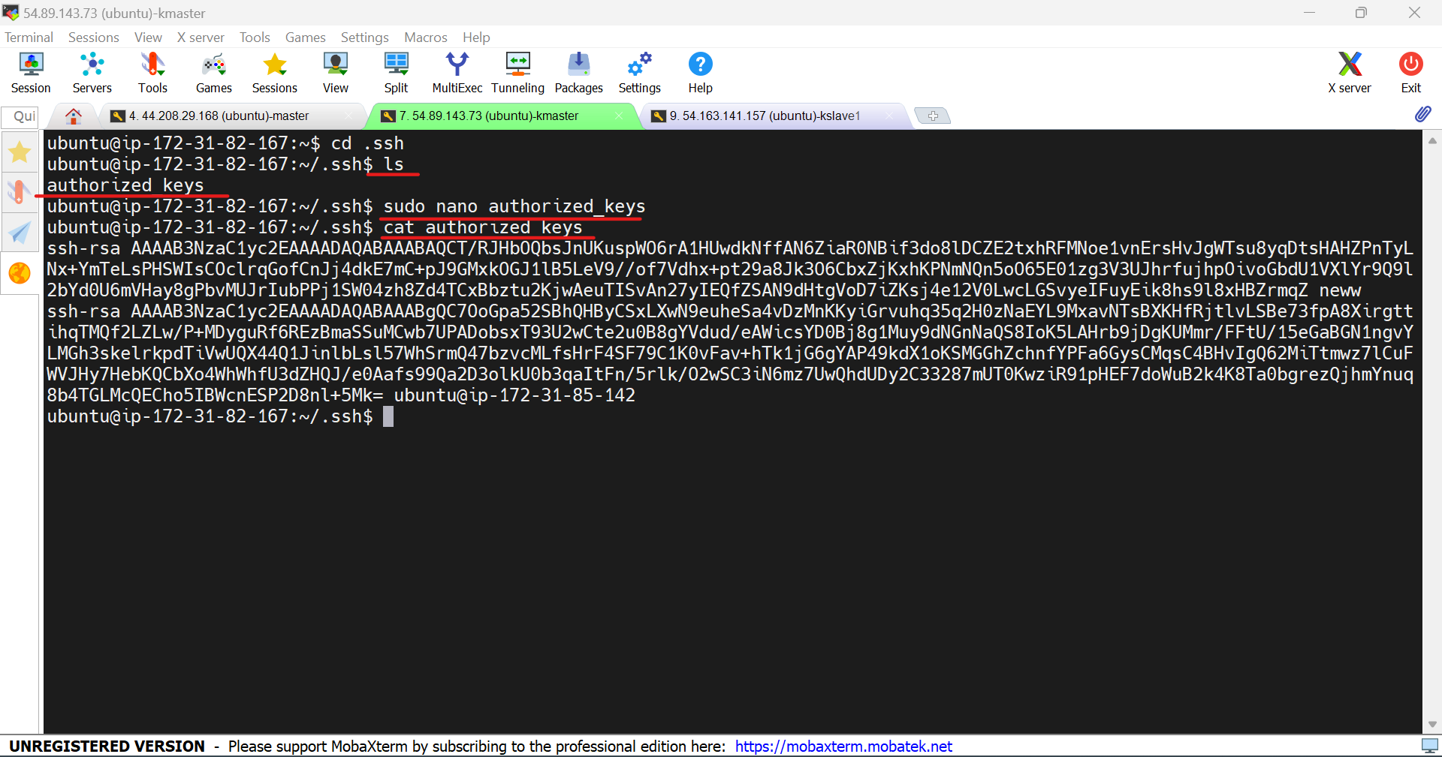

10.Create a master.sh , kmaster.sh , kslave.sh file to execute commands in form of scripts in the master machine.

Go to the /etc/ansible/ path and create the files.

**Master.sh**

sudo apt-get install openjdk-11-jdk -y

sudo apt-get install docker.io -y

sudo wget -O /usr/share/keyrings/jenkins-keyring.asc \

https://pkg.jenkins.io/debian-stable/jenkins.io-2023.key

echo deb [signed-by=/usr/share/keyrings/jenkins-keyring.asc] \

https://pkg.jenkins.io/debian-stable binary/ | sudo tee \

/etc/apt/sources.list.d/jenkins.list > /dev/null

sudo apt-get update

sudo apt-get install jenkins -y

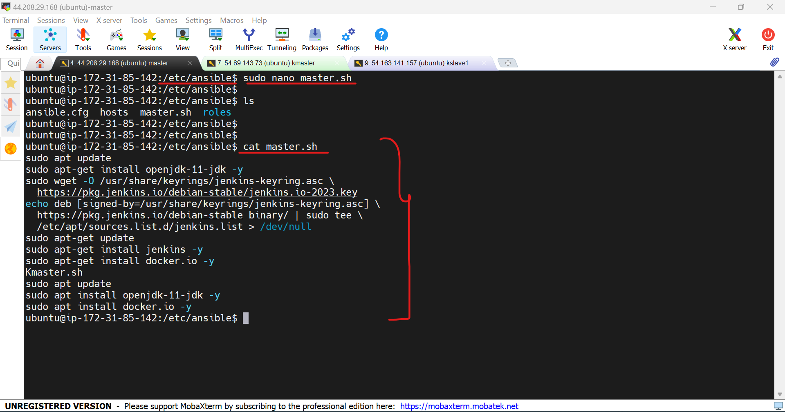

**Kmaster.sh**

sudo apt install openjdk-11-jdk -y

sudo apt-get update

sudo apt install docker.io -y

sudo apt-get install -y apt-transport-https ca-certificates curl gpg

sudo mkdir -p -m 755 /etc/apt/keyrings

curl -fsSL https://pkgs.k8s.io/core:/stable:/v1.28/deb/Release.key | sudo gpg --dearmor -o /etc/apt/keyrings/kubernetes-apt-keyring.gpg

echo 'deb [signed-by=/etc/apt/keyrings/kubernetes-apt-keyring.gpg] https://pkgs.k8s.io/core:/stable:/v1.28/deb/ /' | sudo tee /etc/apt/sources.list.d/kubernetes.list

sudo apt-get update

sudo apt-get install -y kubelet kubeadm kubectl

sudo systemctl enable --now kubelet

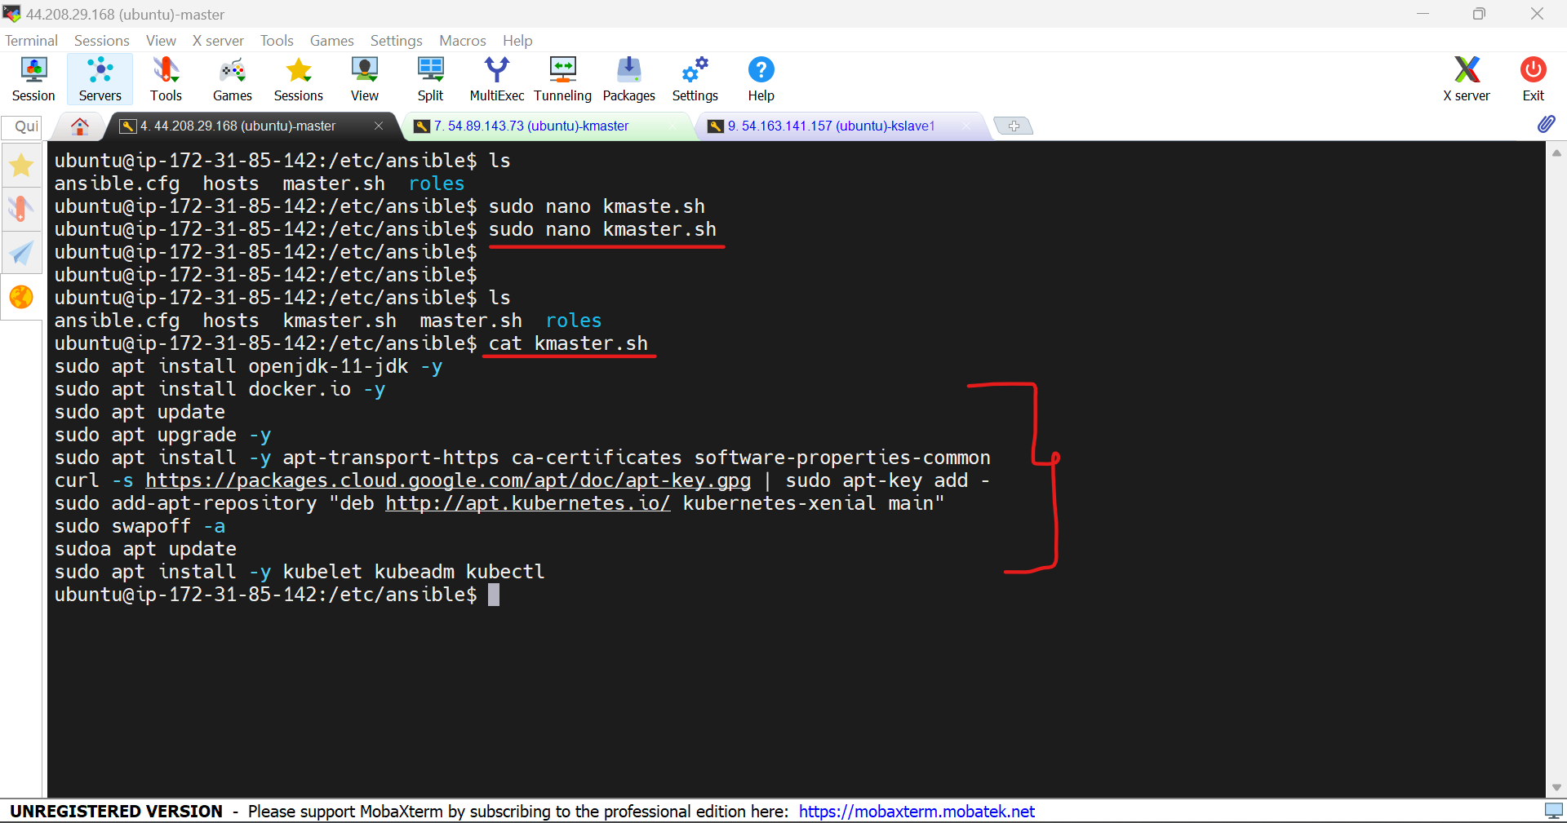

**Kslave.sh**

sudo apt install openjdk-11-jdk -y

sudo apt-get update

sudo apt install docker.io -y

sudo apt-get install -y apt-transport-https ca-certificates curl gpg

sudo mkdir -p -m 755 /etc/apt/keyrings

curl -fsSL https://pkgs.k8s.io/core:/stable:/v1.28/deb/Release.key | sudo gpg --dearmor -o /etc/apt/keyrings/kubernetes-apt-keyring.gpg

echo 'deb [signed-by=/etc/apt/keyrings/kubernetes-apt-keyring.gpg] https://pkgs.k8s.io/core:/stable:/v1.28/deb/ /' | sudo tee /etc/apt/sources.list.d/kubernetes.list

sudo apt-get update

sudo apt-get install -y kubelet kubeadm kubectl

sudo systemctl enable --now kubelet

This commands has been installed after the commands mentioned in the image below.

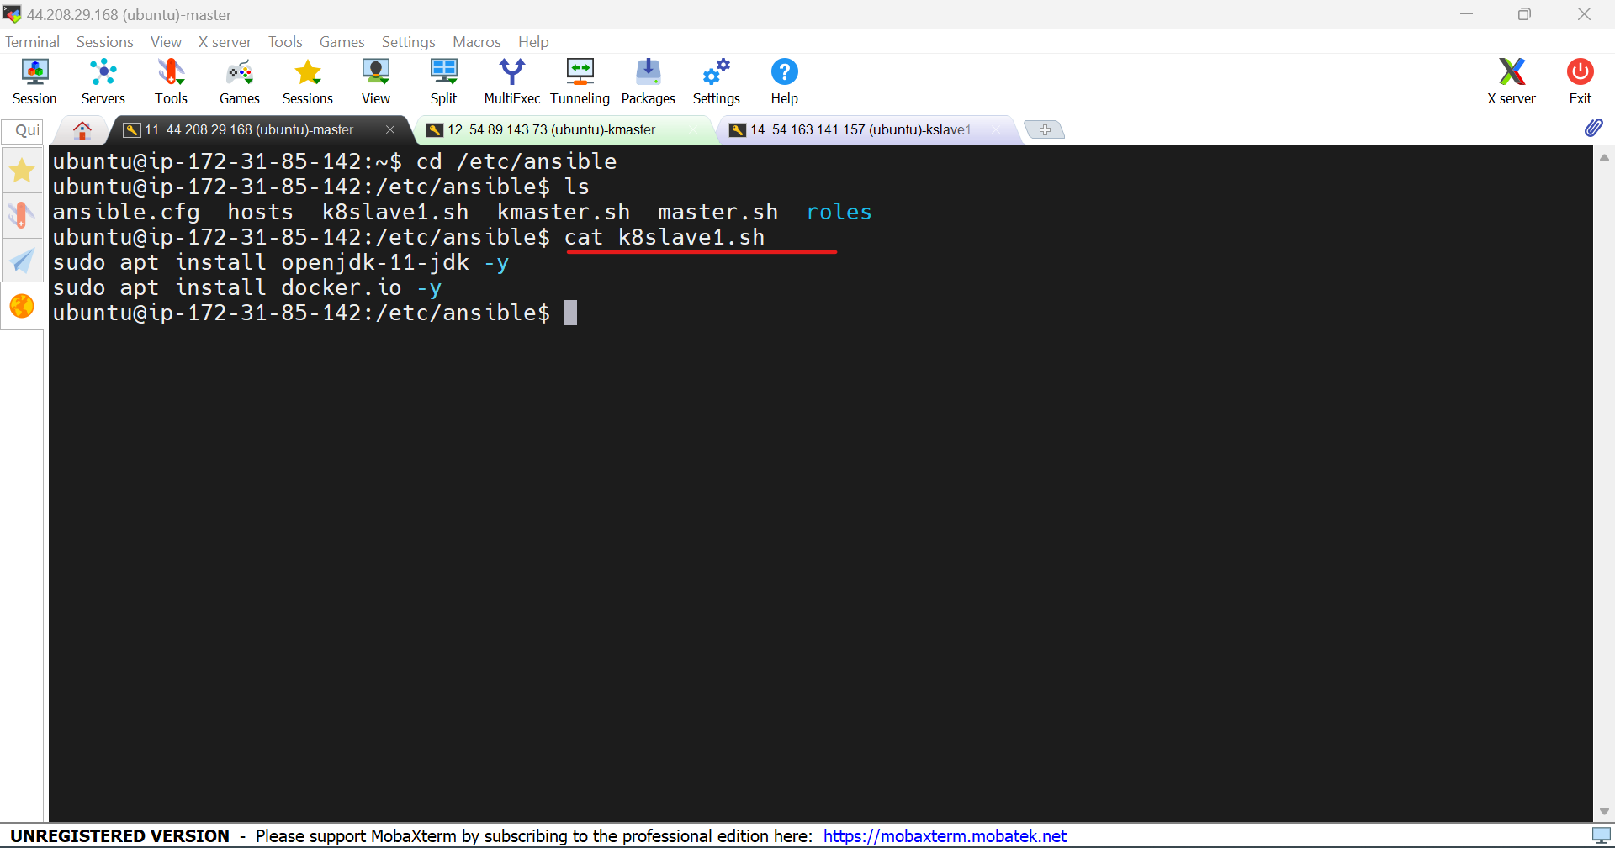

11.Create a playbook to execute the scripts in the kmaster and kslave.

---

- name: Installations on Master

hosts: localhost

become: true

tasks:

- name: Executing script on master

script: master.sh

- name: Installations on kmaster

hosts: kmaster

become: true

tasks:

- name: Executing script on Kmaster

script: kmaster.sh

- name: Installations on kslave

hosts: kmaster

become: true

tasks:

- name: Executing script on kmaster

script: kslave.sh

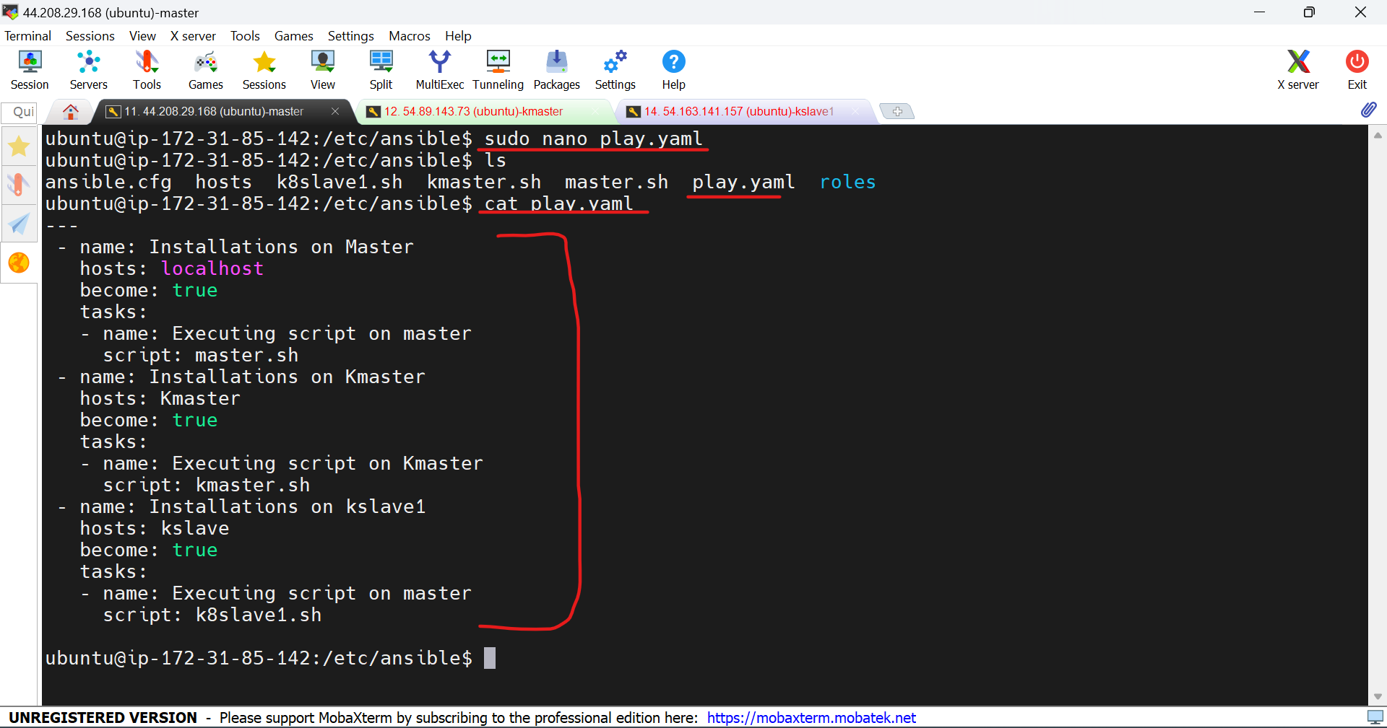

12.Go to host path and add the ip address of the kmaster and kslave to communicate and execute the commands in them.

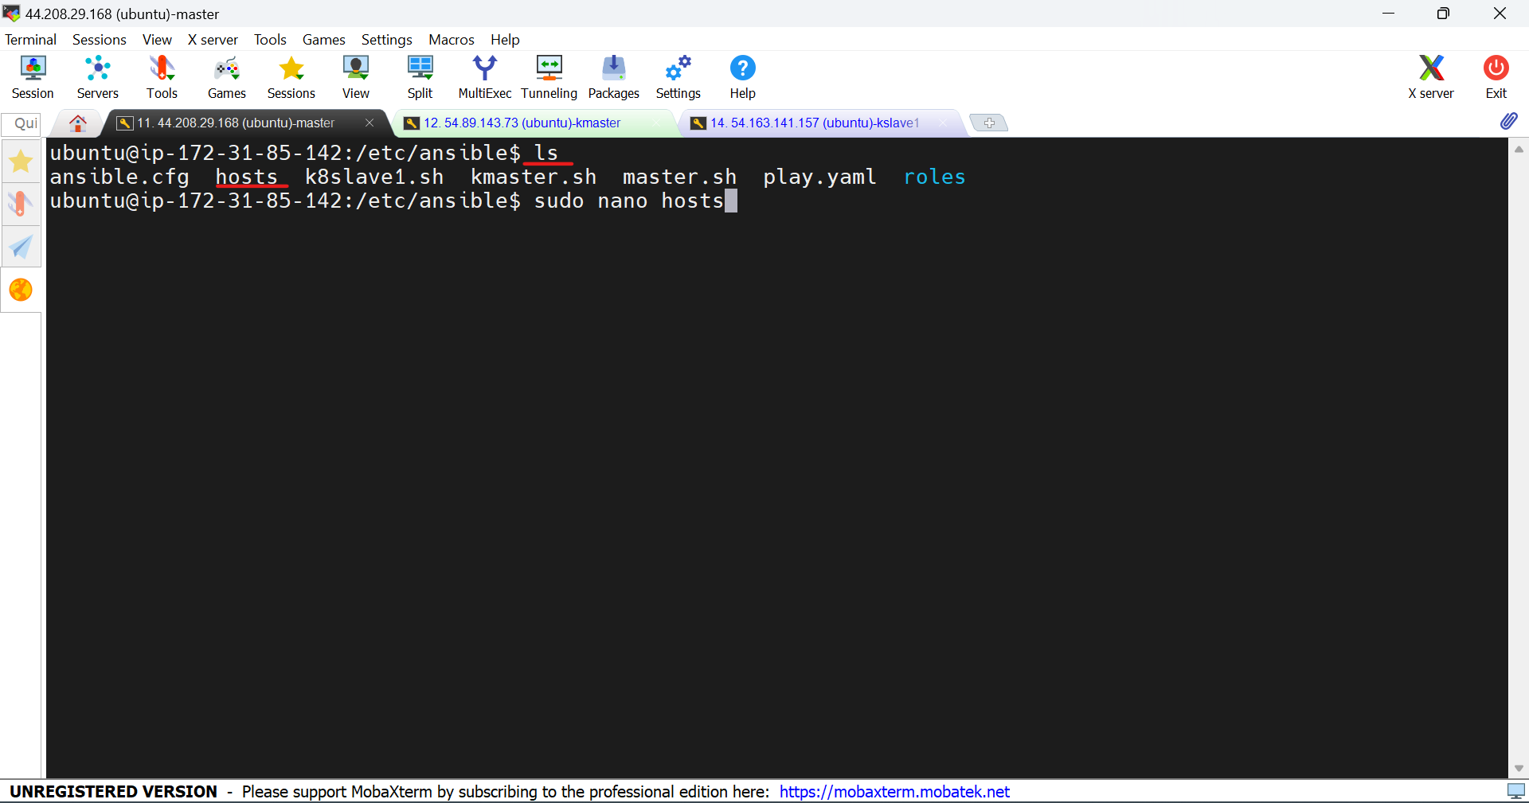

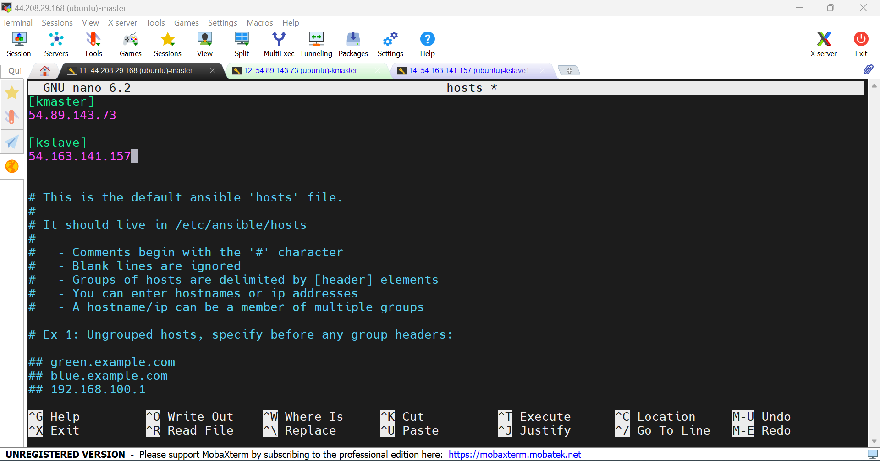

13.Use the command  **ansible-playbook “file name”**

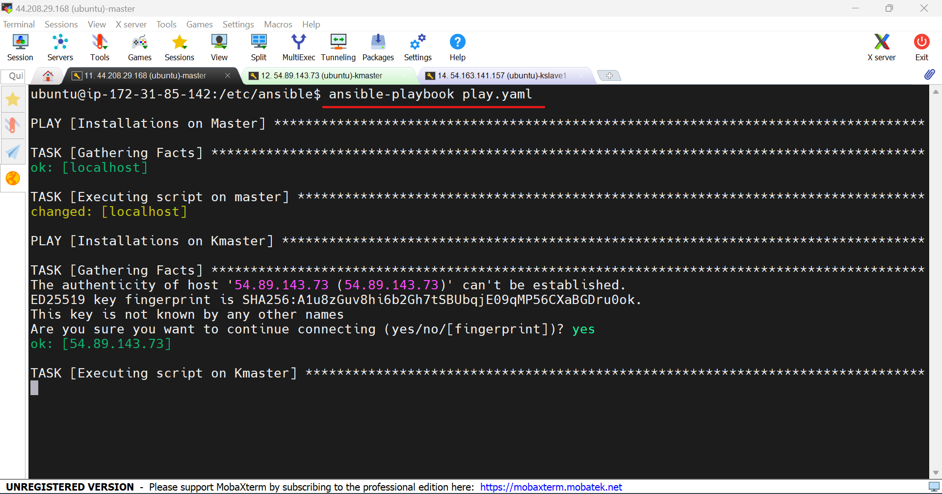

14.java, docker and Jenkins installed in master.

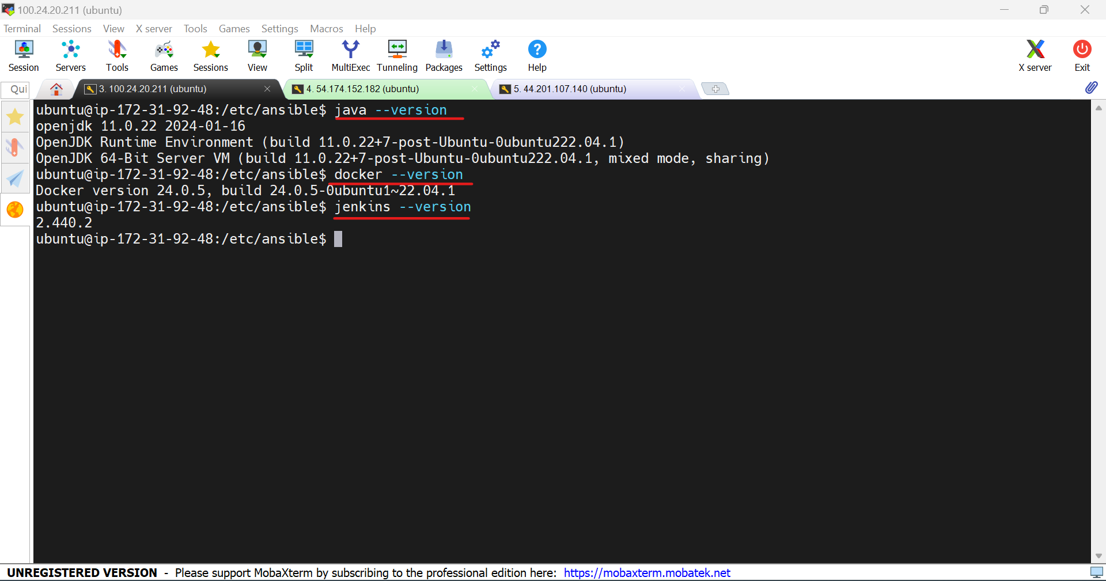

15.java, kubelet, kubeadm, kubectl has been installed in kmaster and kslave.

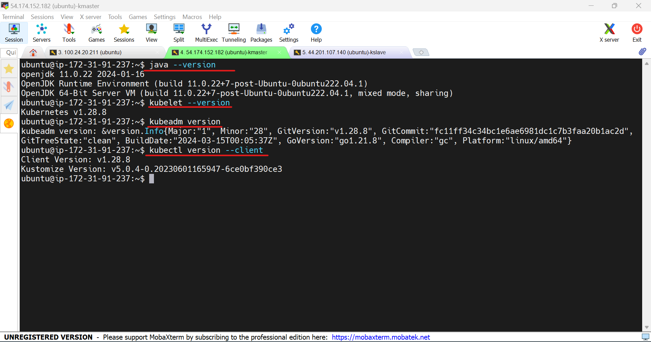

16.In kmaster machine use the command **sudo kubeadm init**

to generate a token.

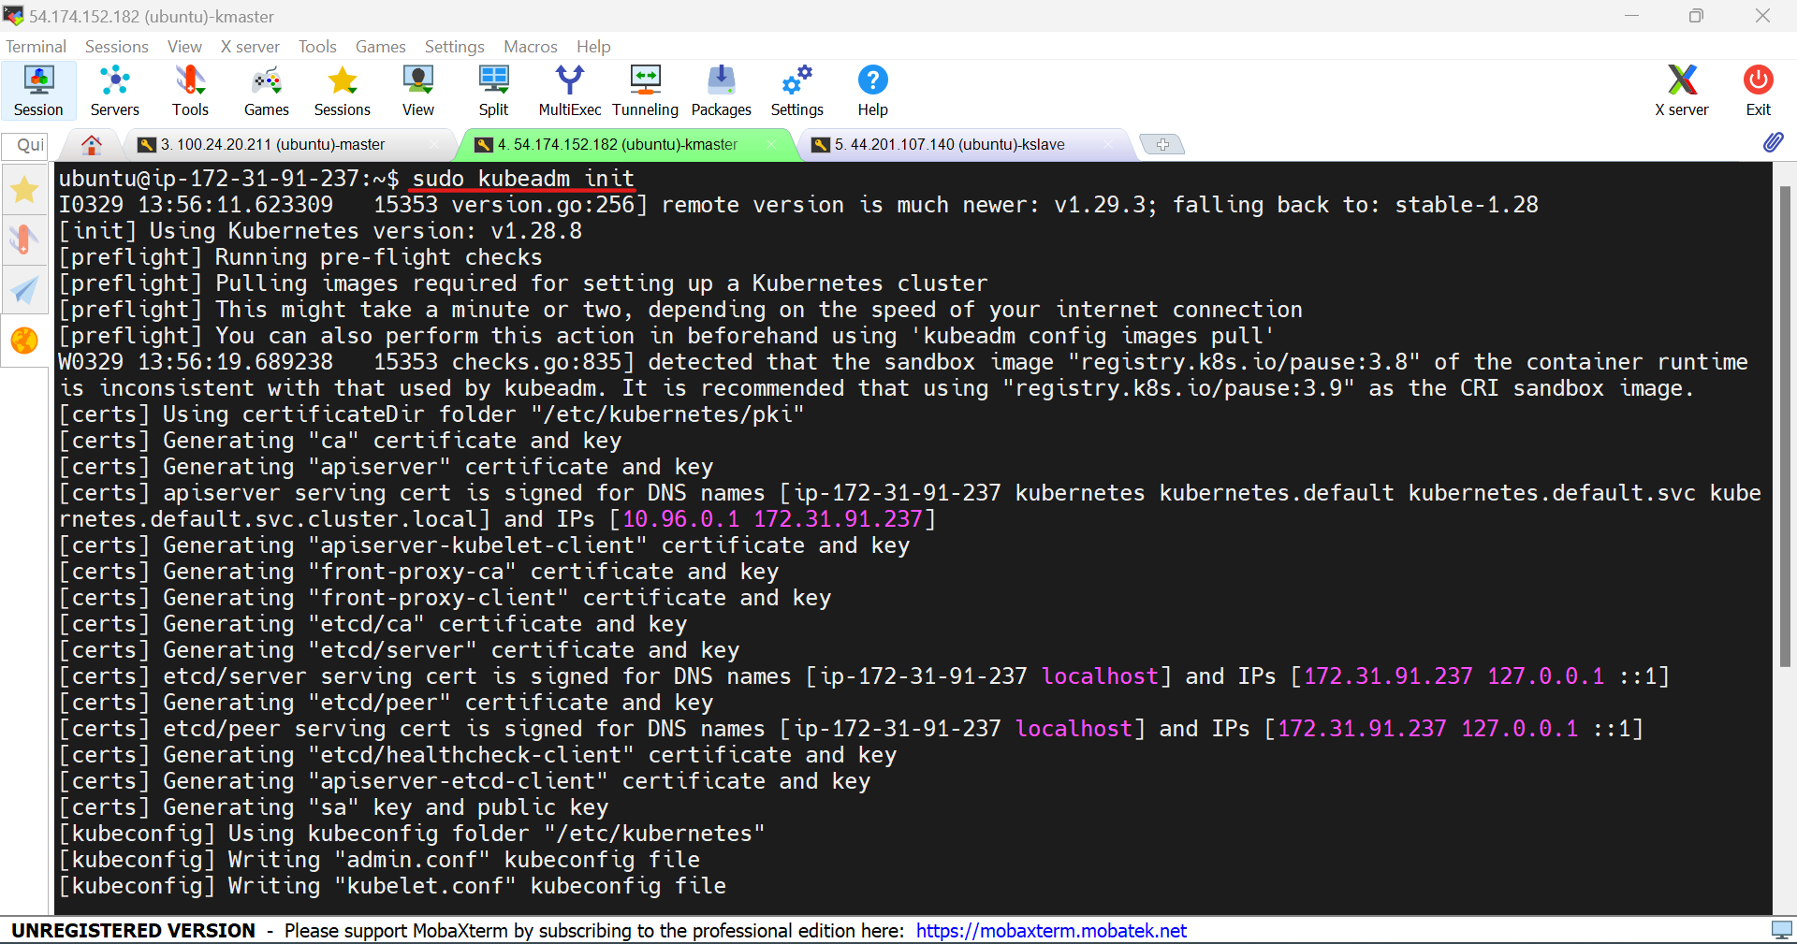

17.Token has been generated. Copy the token and paste it in the kslave.

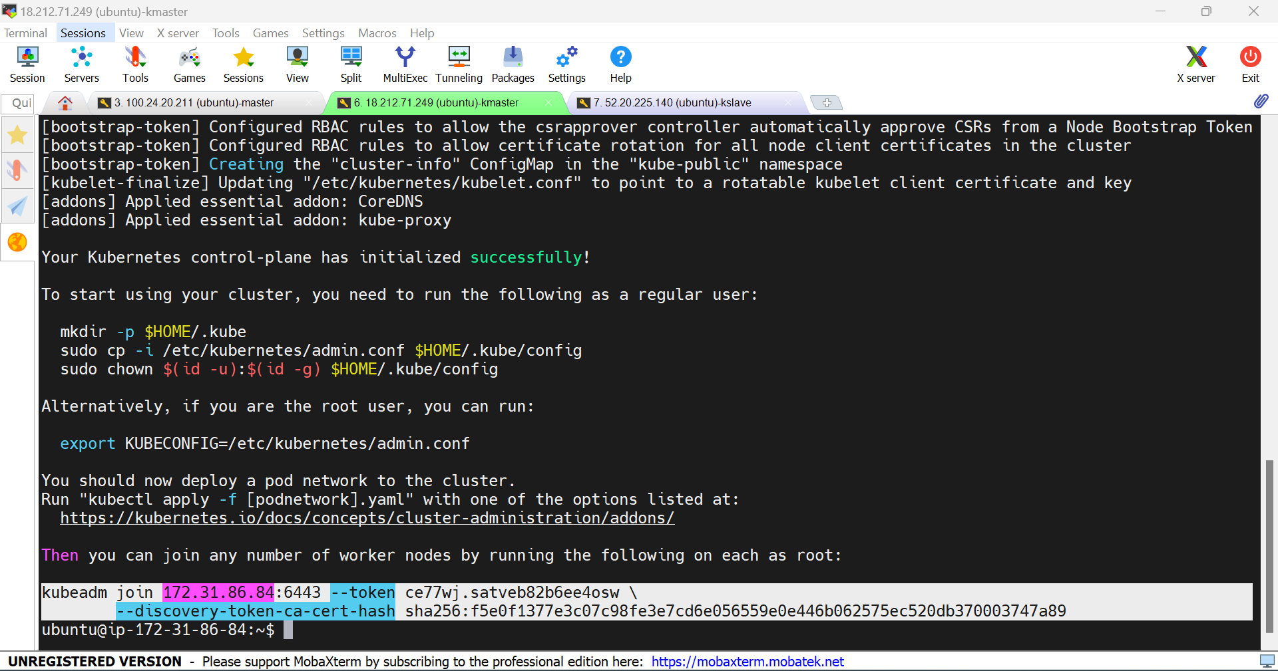

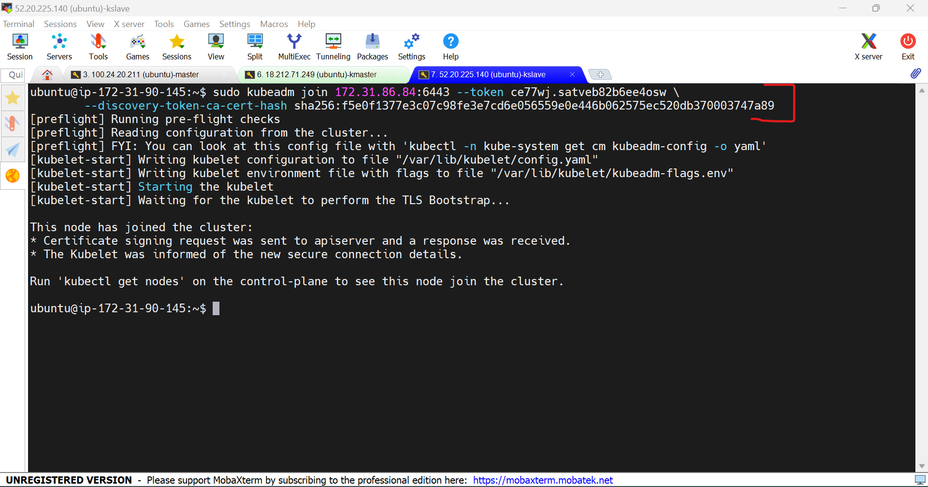

18.In kmaster, use the commands

mkdir -p $HOME/.kube

sudo cp -i /etc/kubernetes/admin.conf $HOME/.kube/config

sudo chown $(id -u):$(id -g) $HOME/.kube/config

kubectl apply -f <https://github.com/weaveworks/weave/releases/download/v2.8.1/weave-daemonset-k8s.yaml>

kubectl get nodes

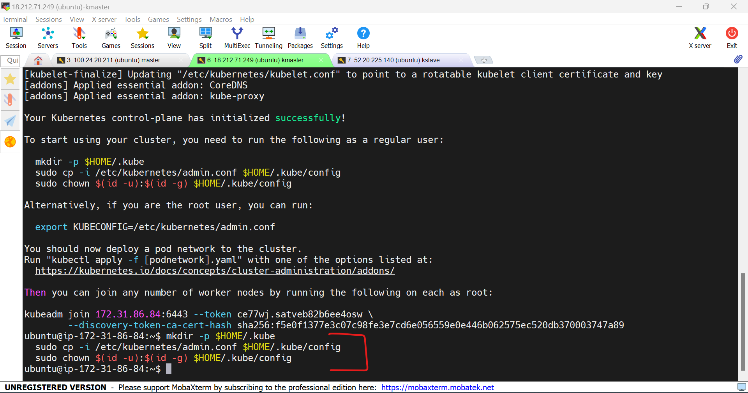

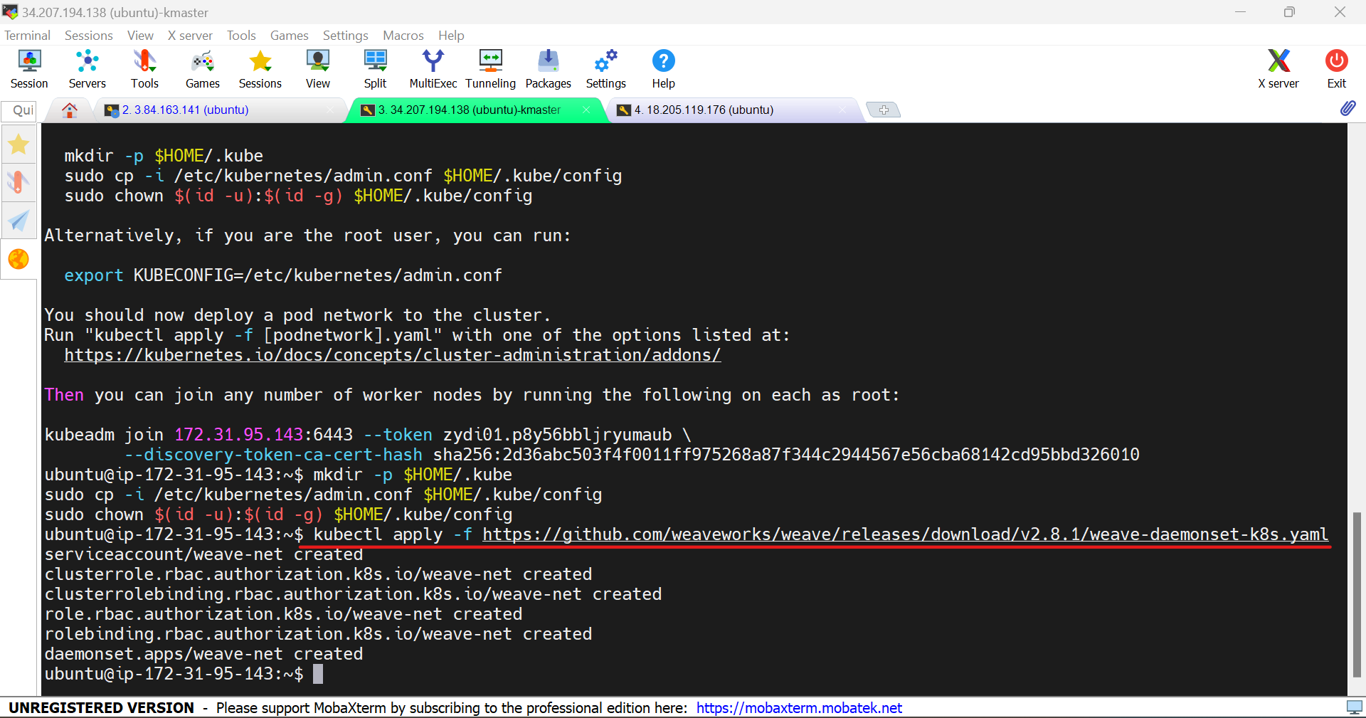

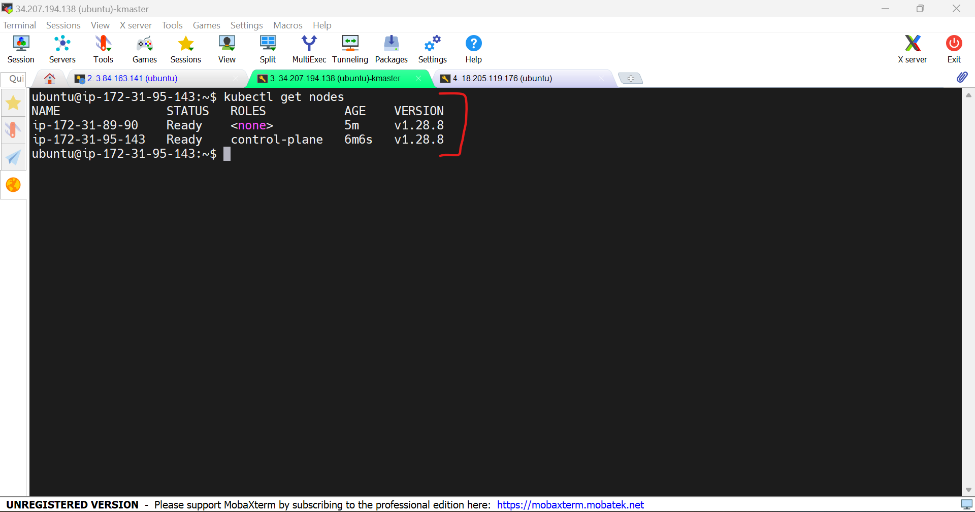

20.Copy the ip address of the Jenkins master open it with port 8080 in the browser.

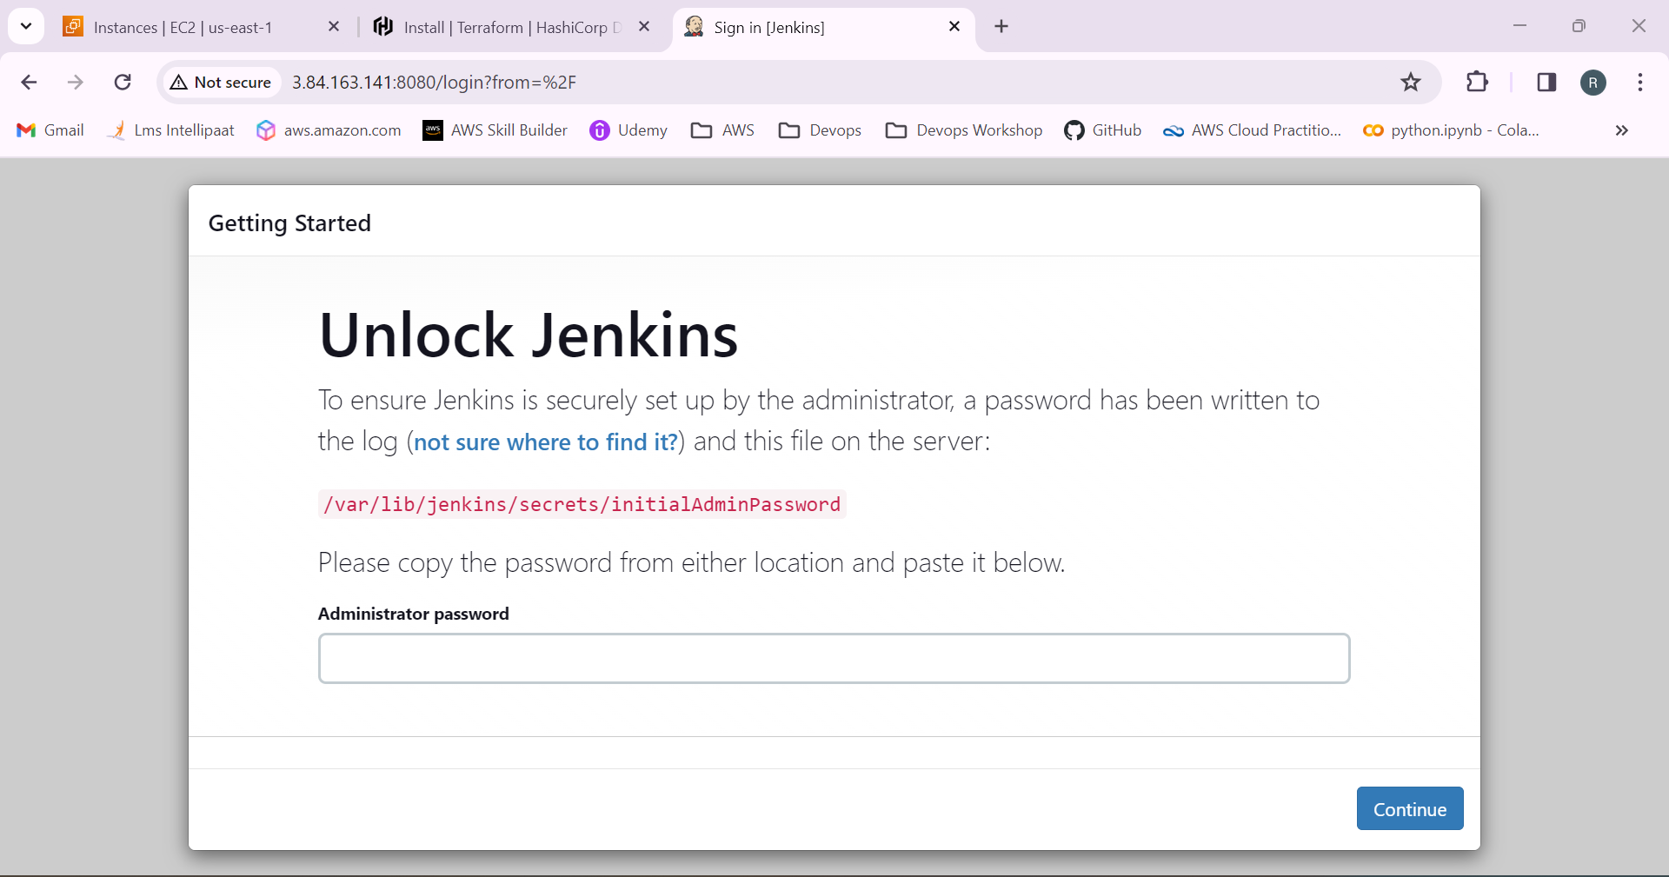

21.Copy the password from the /var/lib/Jenkins/secrets/initialAdminPassword and use it.

Install suggested plugins.

Create an Jenkins addmin user.

Jenkins login is successfull.

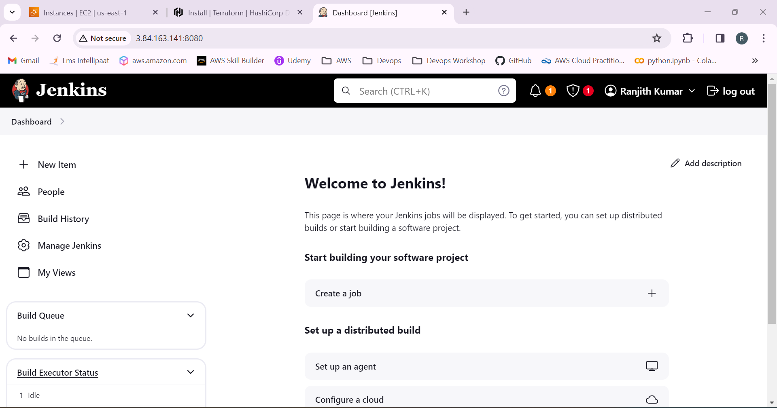

22.Go to manage Jenkins > nodes and add the kmaster and kslave.

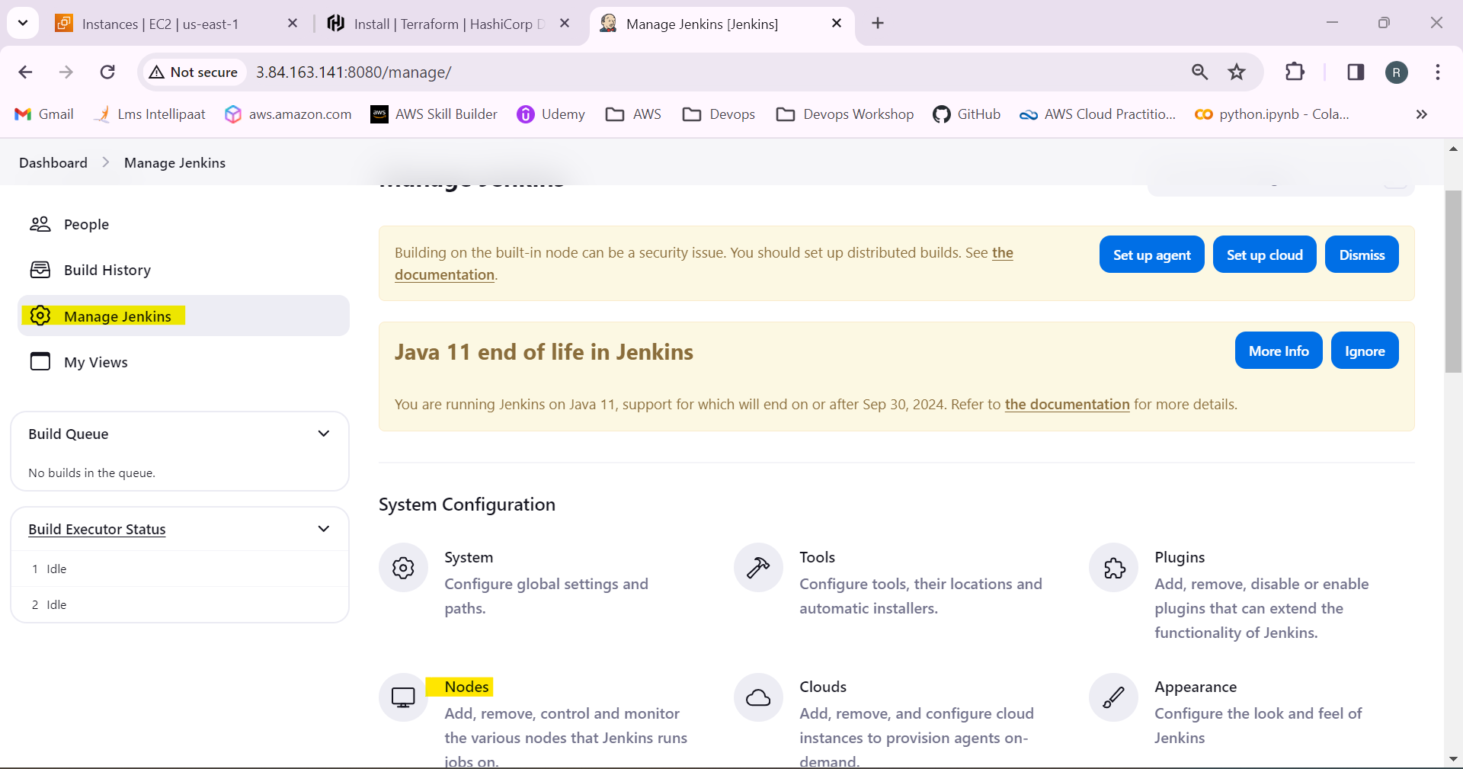

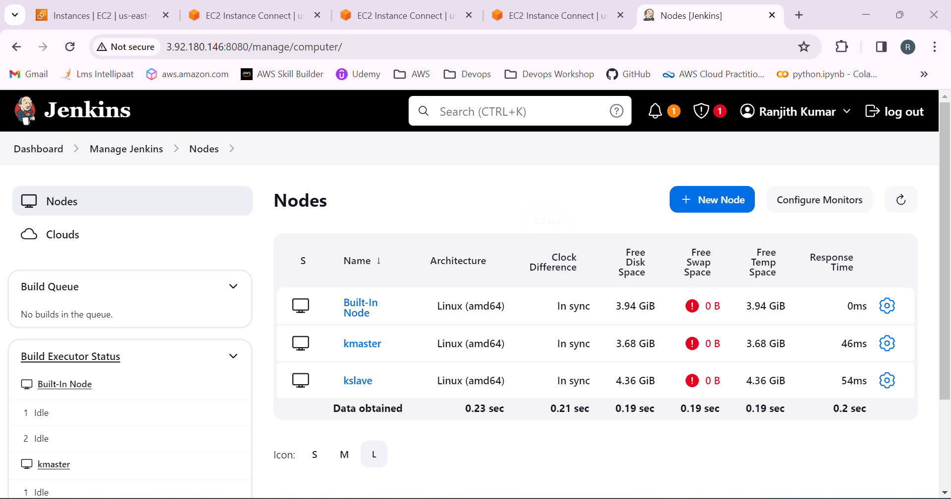

23.Now open the the github link and fork to our repository.

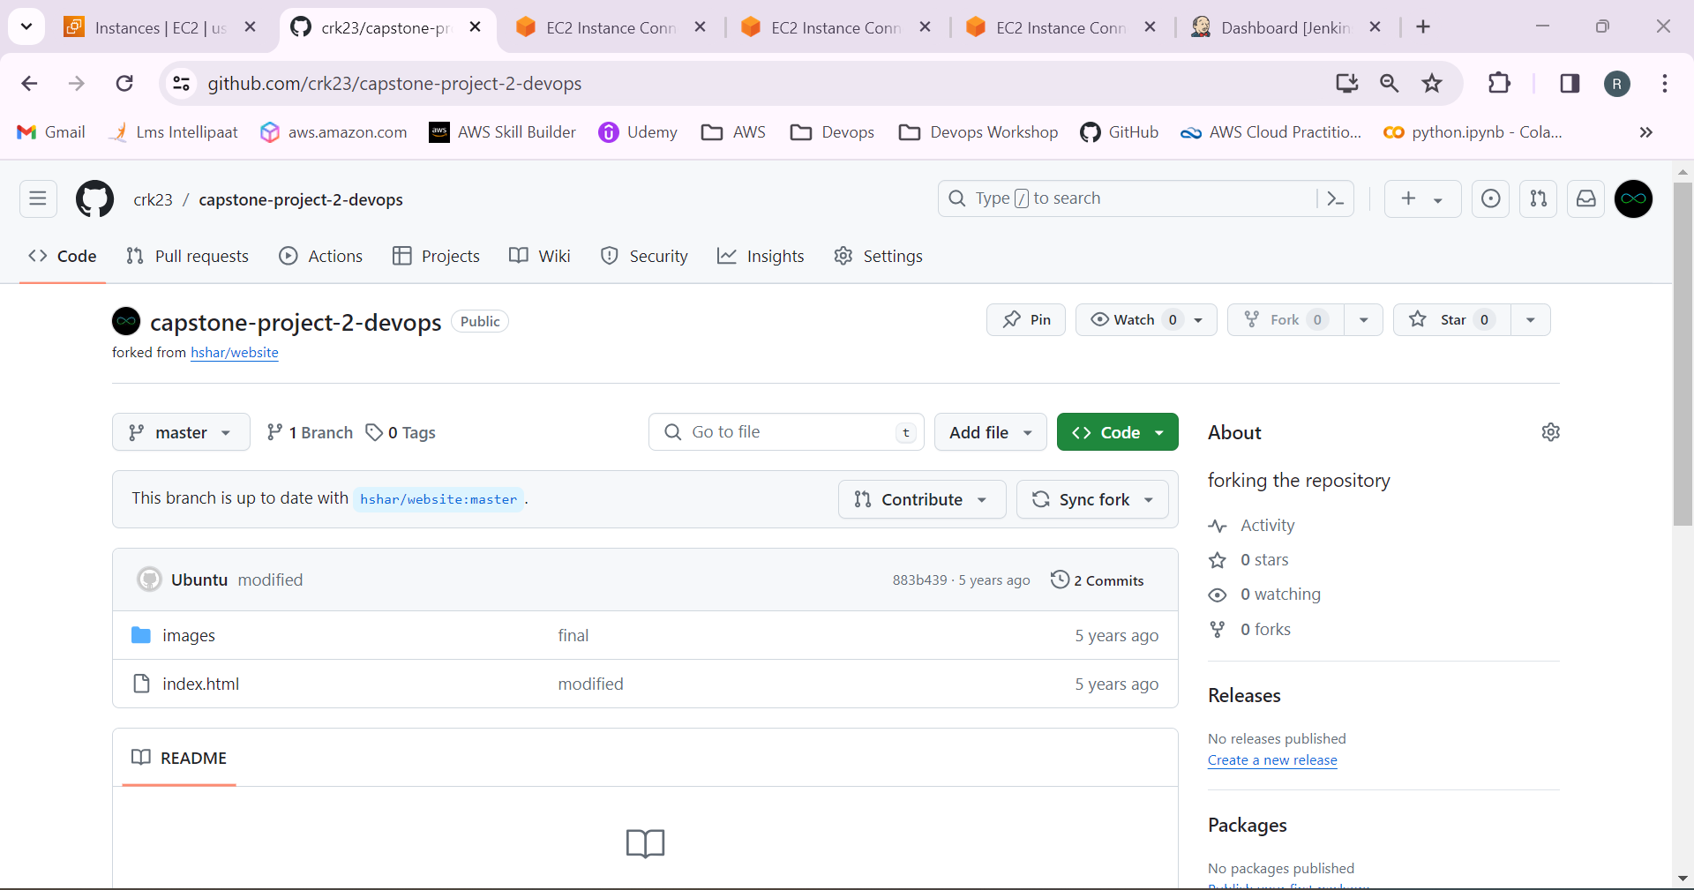

24.In master, use the command  **git clone “link of the repository”**  to clone the repository.

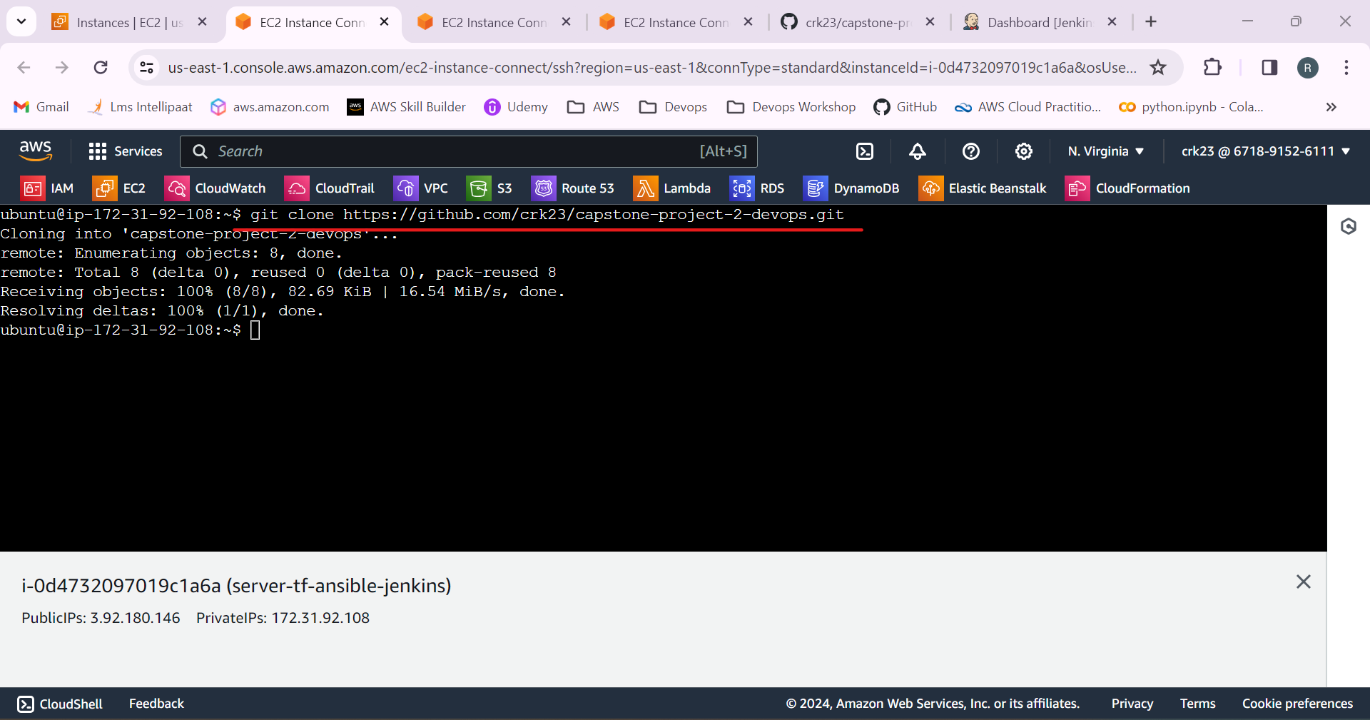

25.Go to the repository location and create a docker file

FROM ubuntu

RUN apt update

RUN apt-get install apache2 -y

ADD . /var/www/html

ENTRYPOINT apachectl -D FOREGROUND

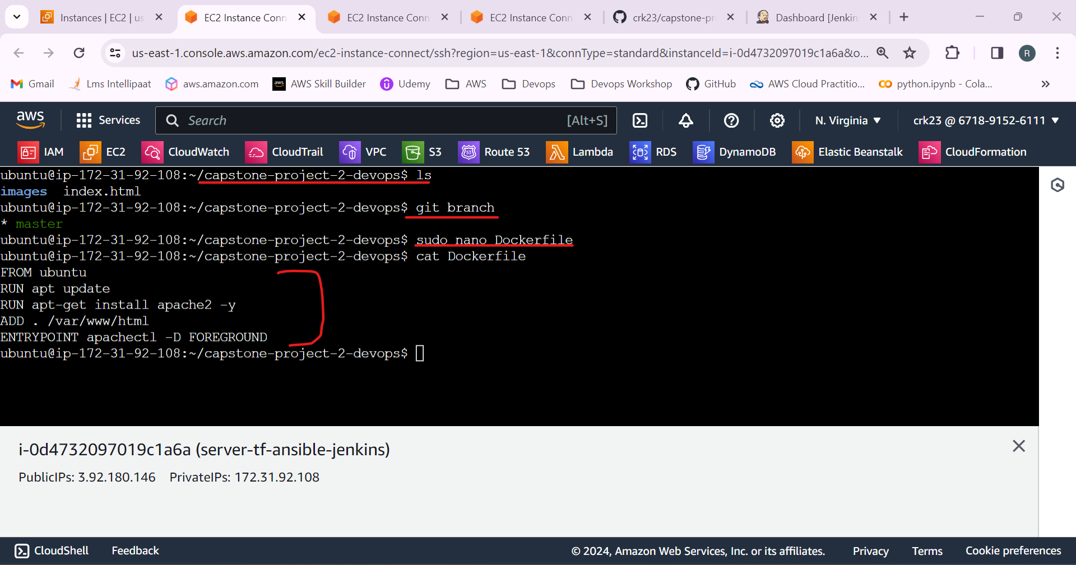

26.Create a deployment.yaml file.

apiVersion: apps/v1

kind: Deployment

metadata:

name: project-deployment

labels:

app: project

spec:

replicas: 2

selector:

matchLabels:

app: project

template:

metadata:

labels:

app: project

spec:

containers:

- name: project

image: crk23/projectimage

ports:

- containerPort: 80

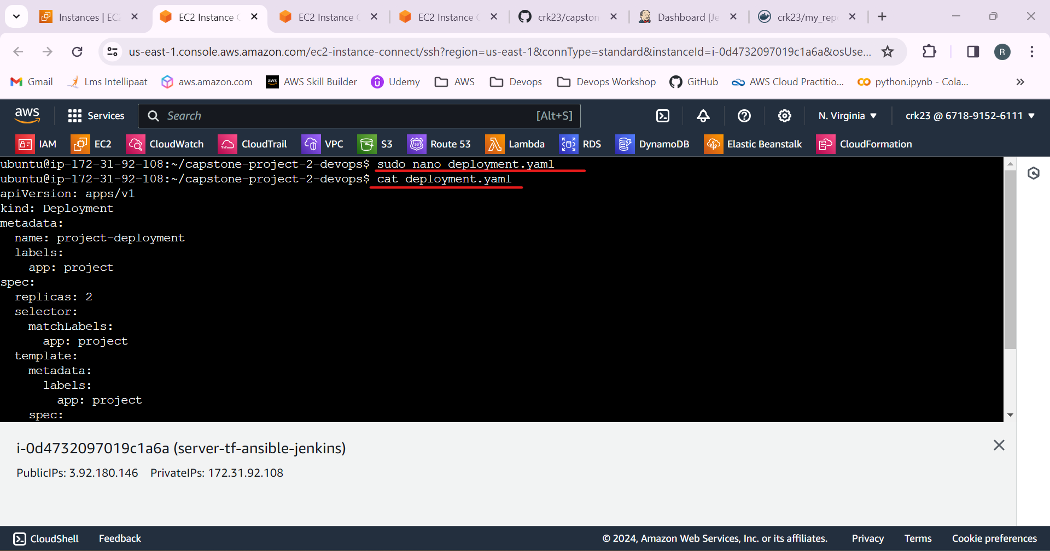

27.Create a service.yaml file.

apiVersion: v1

kind: Service

metadata:

name: production-deployment

spec:

type: NodePort

ports:

- targetPort: 80

port: 80

nodePort: 30008

selector:

app: project

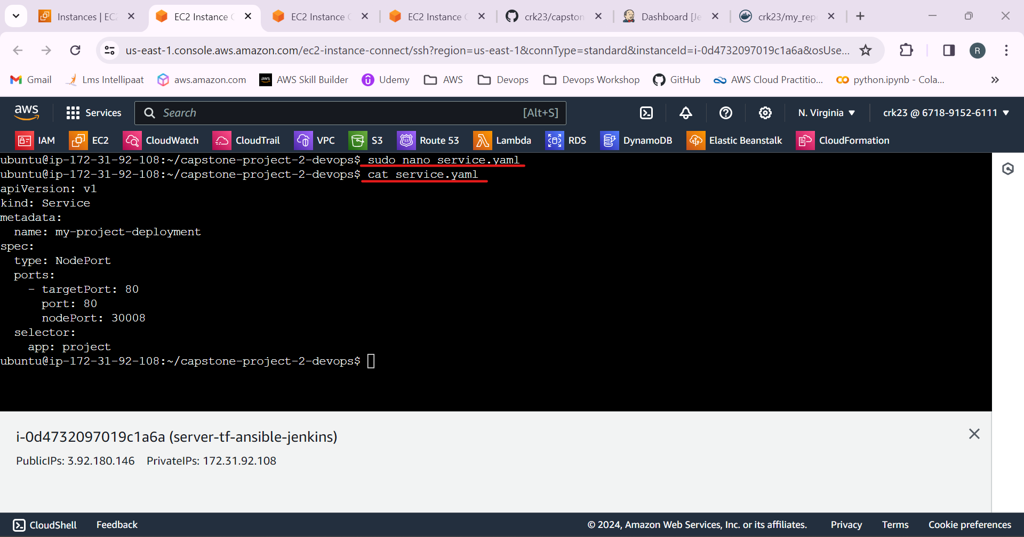

28.Use the commands **git add , git commit -m “any message”**

**Git status** to add and save the changes.

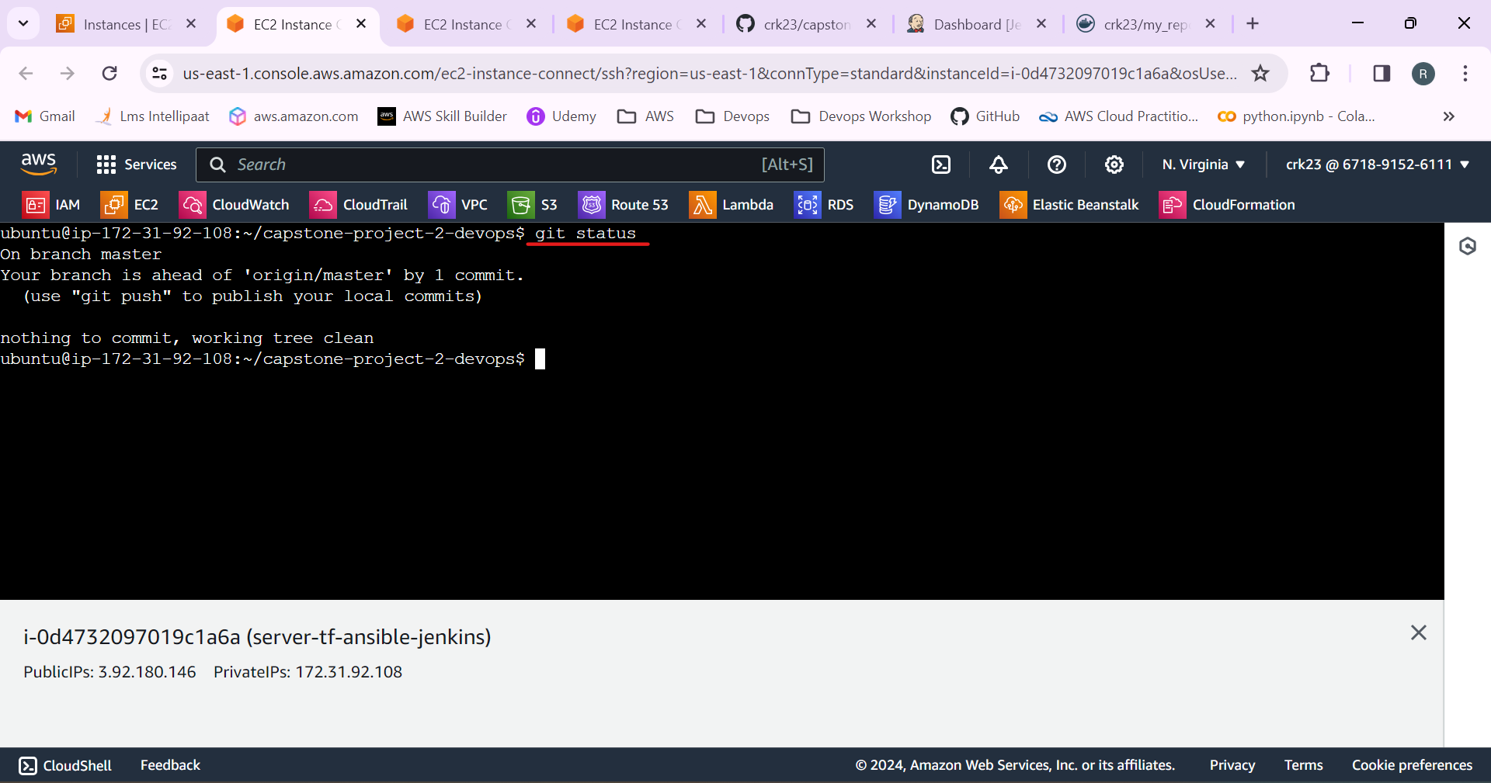

29.Create job in Jenkins.

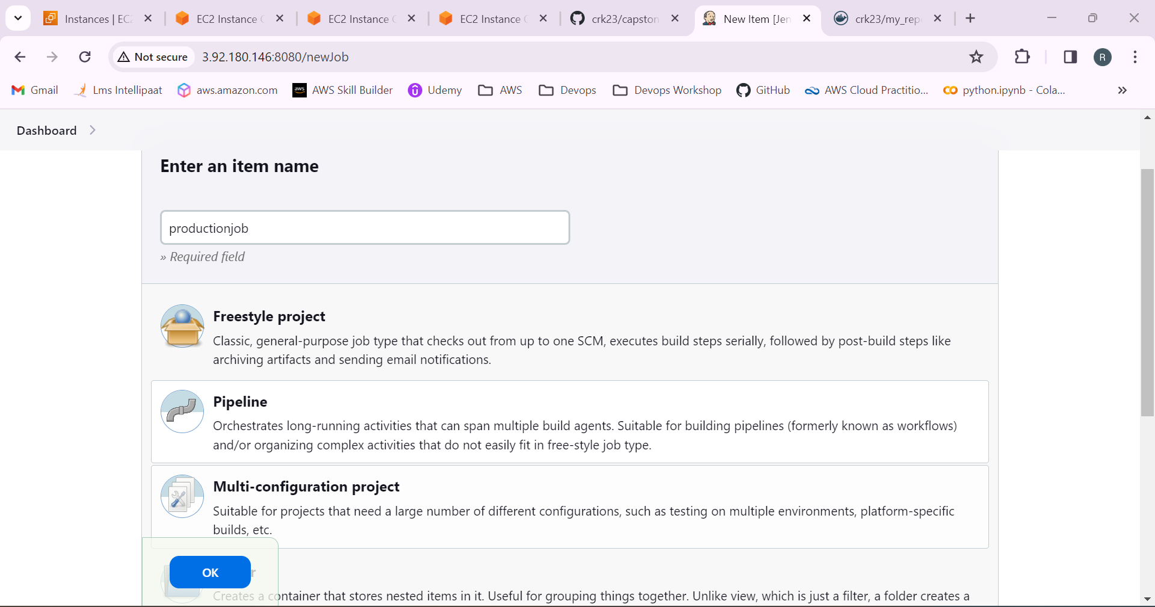

Give description

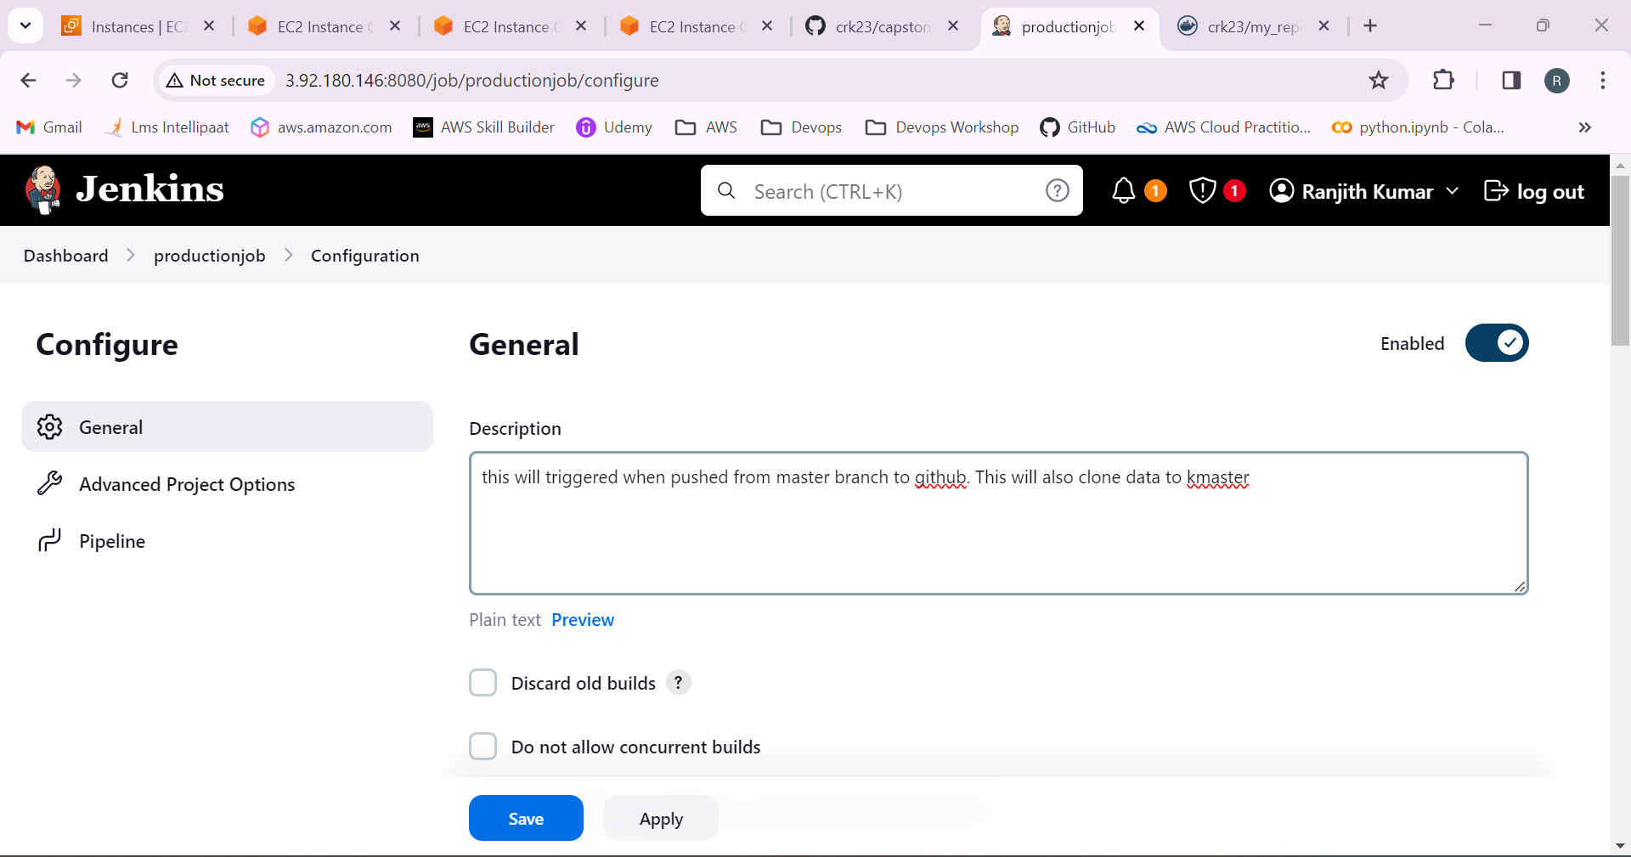

Add the github link in the github project and source code management.

The job will be running on the kmaster

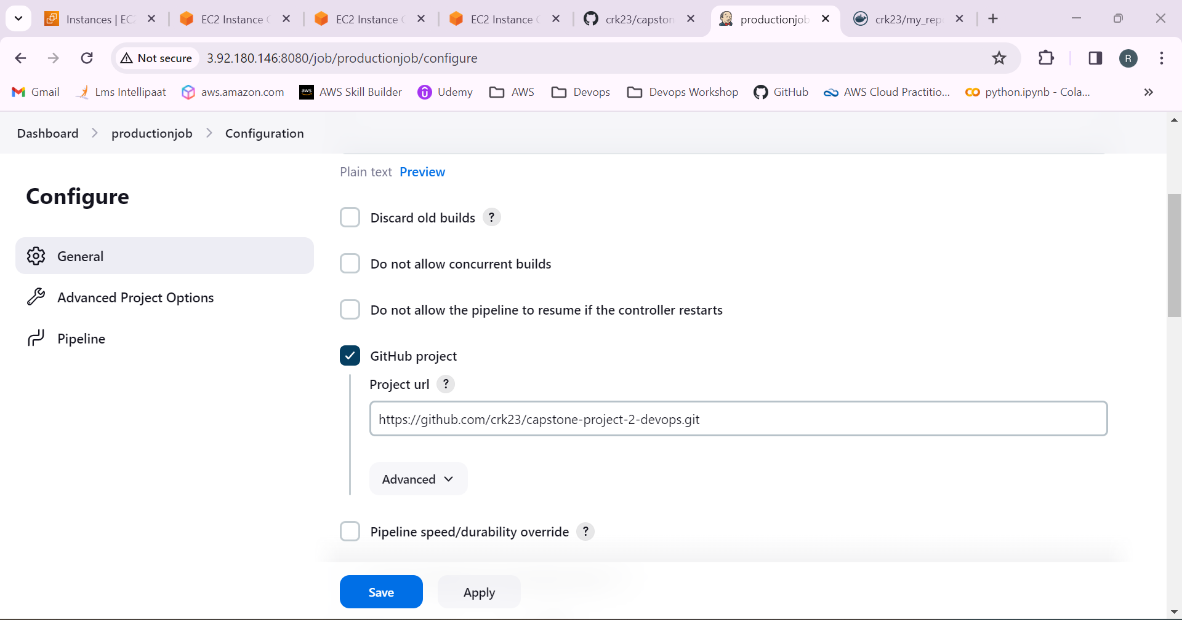

In build triggers select github hook trigger for gitscm polling.

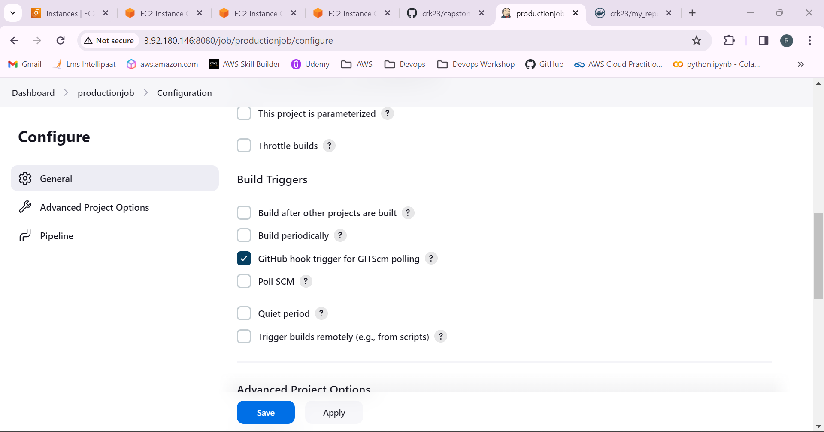

In github repository settings go to webhook and create a webhook.

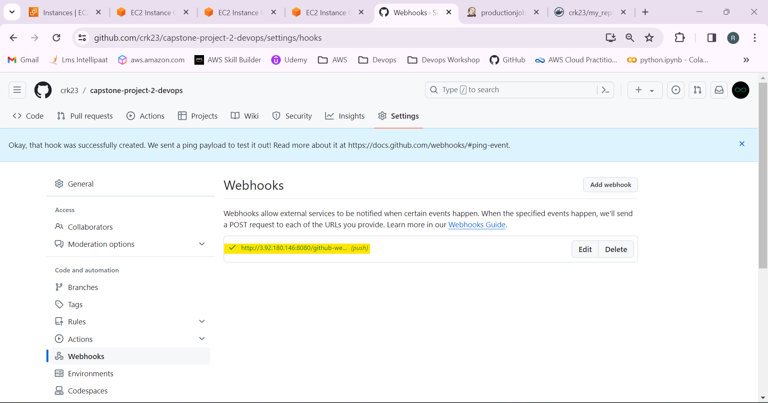

Go to the manage Jenkins > credentials and add the dockerhub username and password to add it in the pipeline script to push the image to the docker hub.

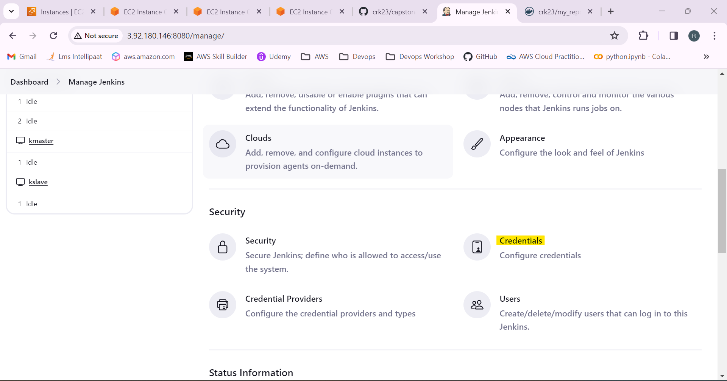

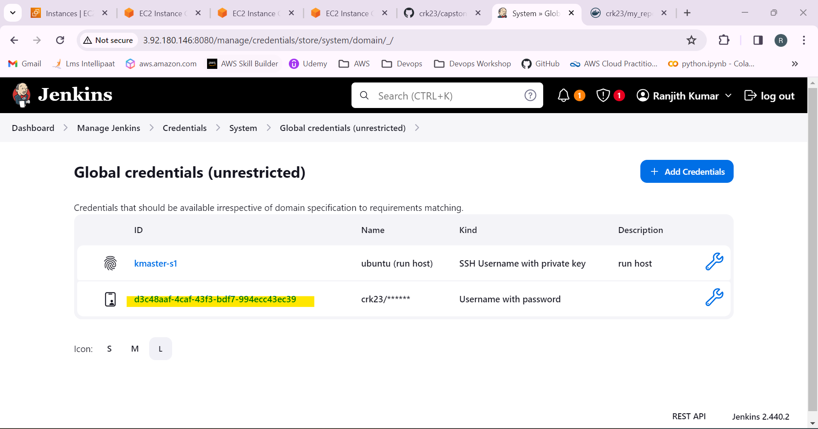

In pipeline use the script.

pipeline{

agent none

environment {

DOCKERHUB_CREDENTIALS=credentials('7ae8b9a4-000a-4515-a9f7-4950cbe8696b')

}

stages{

stage('Hello'){

agent{

label 'kmaster'

}

stage('git'){

agent{

label 'kmaster'

}

steps{

git'https://github.com/Intellipaat-Training/Test.git'

}

}

stage('docker') {

agent {

label 'kmaster'

}

steps {

sh 'sudo docker build /home/ubuntu/jenkins/workspace/FinalProject -t docker6767/image'

sh 'sudo echo $DOCKERHUB_CREDENTIALS_PSW | sudo docker login -u $DOCKERHUB_CREDENTIALS_USR --password-stdin'

sh 'sudo docker push crk23/projectimage'

}

}

stage('Kubernetes') {

agent {

label 'kmaster'

}

steps {

sh 'kubectl create -f deployment.yaml'

sh 'kubectl create -f service.yaml'

}

}

}

}

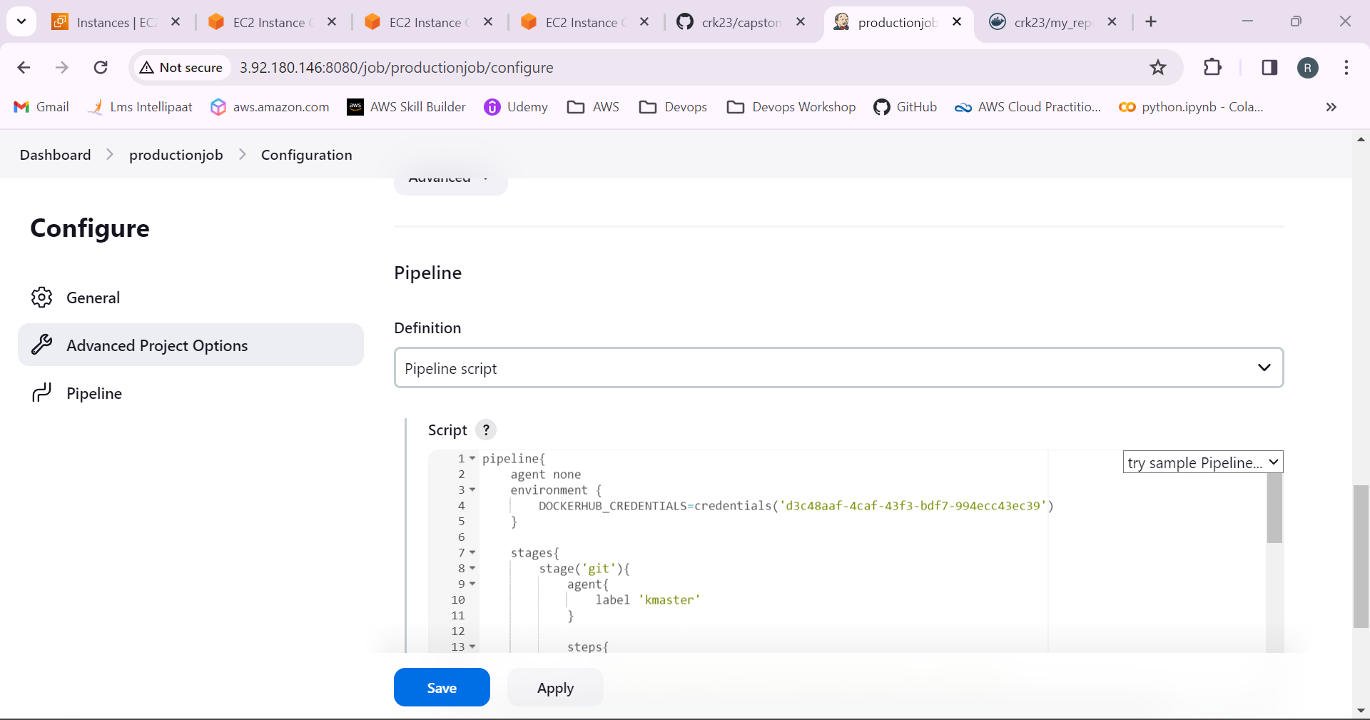

30.Job has been created.

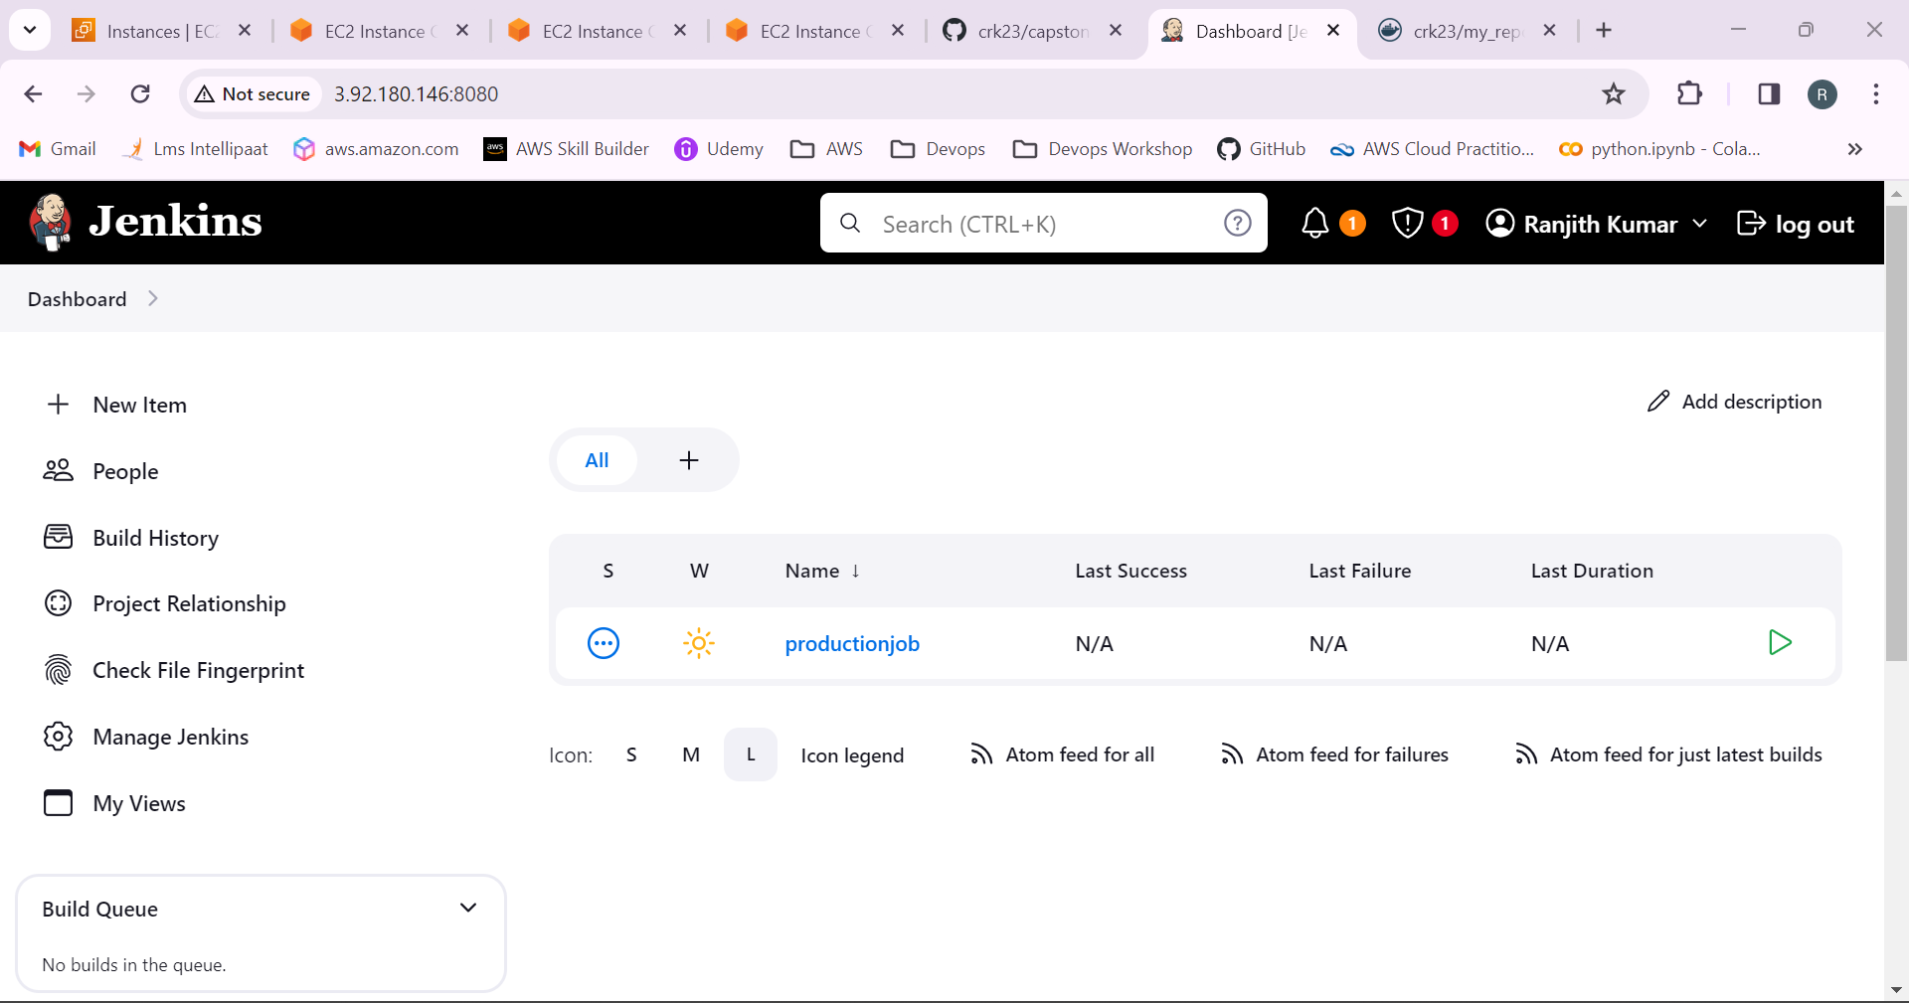

31.Now push the branch to the github.

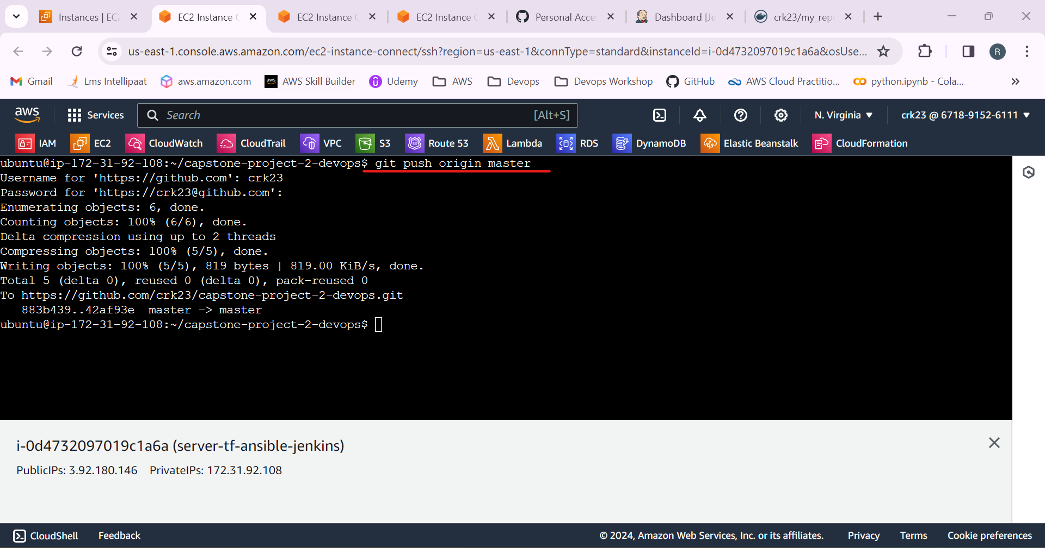

32.Files has been pushed to github.

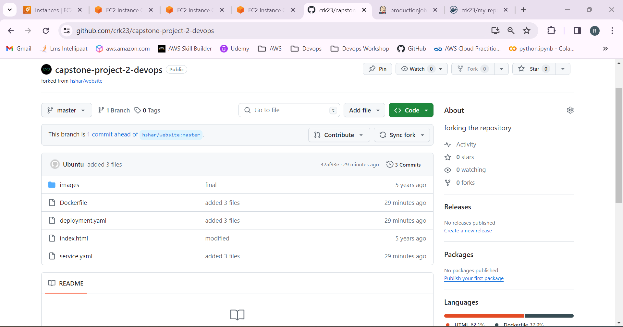

33.The pipeline was trigerred 1st time manually and made some changes in the github and again pushed to the github now the trigger happened.

